Technical Design Specification
ComiVerse - A Digital Comic Platform with Integrated Translation and Content Distribution Tools
CVP - Report 4

Project Name | ComiVerse
Architecture Style | Plugin-Driven Layered Monolith
SRS Reference | SRS v1.1.0
Screen Design Ref | ScreenDesignSpec v1.1.0
TDS Version | v1.1.0
Date Created | 25/5/2026
Last Updated | 09/08/2026
Authors | Bùi Quang Hiệp - HE171337  Bùi Việt Hùng - HE163146  Chu Tuấn Ngọc - HE186006  Nguyễn Xuân Hanh - HE180944  Đặng Ngọc Thành - HE186611
Reviewer | Lê Thị Tú Kiên - Instructor
Status | Approved

Document Change History
Version | Date | Changes | Author
v1.0.0 | 25/05/2026 | Created the initial Technical Design Specification structure and established the baseline architecture for the ComiVerse system. | HiepBQ
v1.0.0 | 04/07/2026 | Completed Part 1 — System Architecture, including architecture rationale, component structure, package organization, technology stack, and deployment architecture. | NgocCT
v1.0.0 | 10/07/2026 | Completed Part 2 — Interface Specification, including interface inventory, JWT authentication design, REST API conventions, representative endpoint contracts, scheduled interfaces, and internal service interfaces. | ThanhDN
v1.0.0 | 14/07/2026 | Added Part 3 — Data Model and Part 4 — Integration & Communication Design, including ERD, database schema strategy, ORM mapping, indexing, migration, external integrations, asynchronous communication, and transaction boundaries. | HanhNX
v1.0.0 | 17/07/2026 | Completed Part 5 — Security Design, including authentication flow, RBAC implementation, data protection, input validation, security headers, and CORS policy. | HanhNX
v1.0.0 | 19/07/2026 | Added and refined Part 6 — Key Algorithms & Business Logic, including state transitions, concurrency handling, transaction boundaries, scheduled jobs, and implementation-level business rules. | ThanhDN
v1.0.0 | 20/07/2026 | Reviewed and standardized the Technical Design Specification; corrected section references, implementation decisions, NFR mappings, interface descriptions, and document consistency. | HungBV
v1.1.0 | 05/08/2026 | Edit part 1 , 2 , 3 , 4 , 5 | All Members
v1.1.0 | 09/08/2026 | Edit all report | All Members

Part 1 — System Architecture

1.1 Architecture Overview & Decision Rationale
Architecture Style: Monolith

Decision | Choice | Rationale | NFR / Constraint Driving It
Architecture style | Plugin-Driven Layered Monolith | Automates 80% of boilerplate CRUD via Spring Plugin and Generics to drastically reduce development overhead while maintaining clean code separation. | NFR-M01: Enforces unified code standards and naming conventions.  NFR-M03: Maintains strict modular and decoupled design principles.
Primary language | Java 21 + Spring Boot 3.5 | Utilizes Java 21's Virtual Threads to cleanly scale high-volume concurrent streaming traffic. Dynamic routing maps endpoints directly to abstract plugins. | Constraint-TEAM: Core team expertise lies within the Spring ecosystem.  NFR-S01: Supports >= 5,000 concurrent users (CCU) without degradation.
Database type | PostgreSQL (with pgvector extension) | Evaluates relational constraints natively while allowing high-dimensional vector similarity calculations (Cosine Distance) straight via indexed SQL. | NFR-P03: Sub-3.0 second query execution on datasets up to 100,000 records.  NFR-S02: Scale database indexing to support >= 1,000,000 chapters.  NFR-A05: Guarantee strict ACID compliance for wallets and financial records.
Auth approach | Stateless JWT (JSON Web Token) | Offloads session lookups entirely onto cryptographically signed tokens, allowing rapid reader movement between chapters without taxing database memory. | NFR-S04: Ensures application services remain completely stateless.  NFR-SEC03: Enables strict Role-Based Access Control (RBAC) across protected routes.
Data Mapping Style | ModelMapper with Object-DTO Isolation | Restricts controllers to DTO interfaces. Shields core persistence layers and schema shapes from direct frontend adjustments. | NFR-M03: Ensures strict modular separation of data.  NFR-C01 / NFR-C04: Controls data boundary, mitigating leakage of user PII.
Soft Delete Pattern | Logical Soft Delete (softDeleteById) | Overrides delete hooks with a logical flag update. Retains record states to preserve downstream dependencies. | NFR-A05: Prevents structural data inconsistency across tables.  NFR-C03 / NFR-C05: Guarantees mandatory data retention of logs and moderation audits
Storage Strategy | Cloudinary (Image Media Management Platform) | Delegates heavy graphic asset delivery, optimization, on-the-fly scaling, and responsive layout compression directly to edge cache endpoints. | NFR-P01: Comic chapter pages must render within 2.0s under load.  NFR-U01: Deliver optimized images matching fluid responsive viewports.  NFR-S02: Manage physical infrastructure storage scalability bounds.

1.2 System / Component Diagram
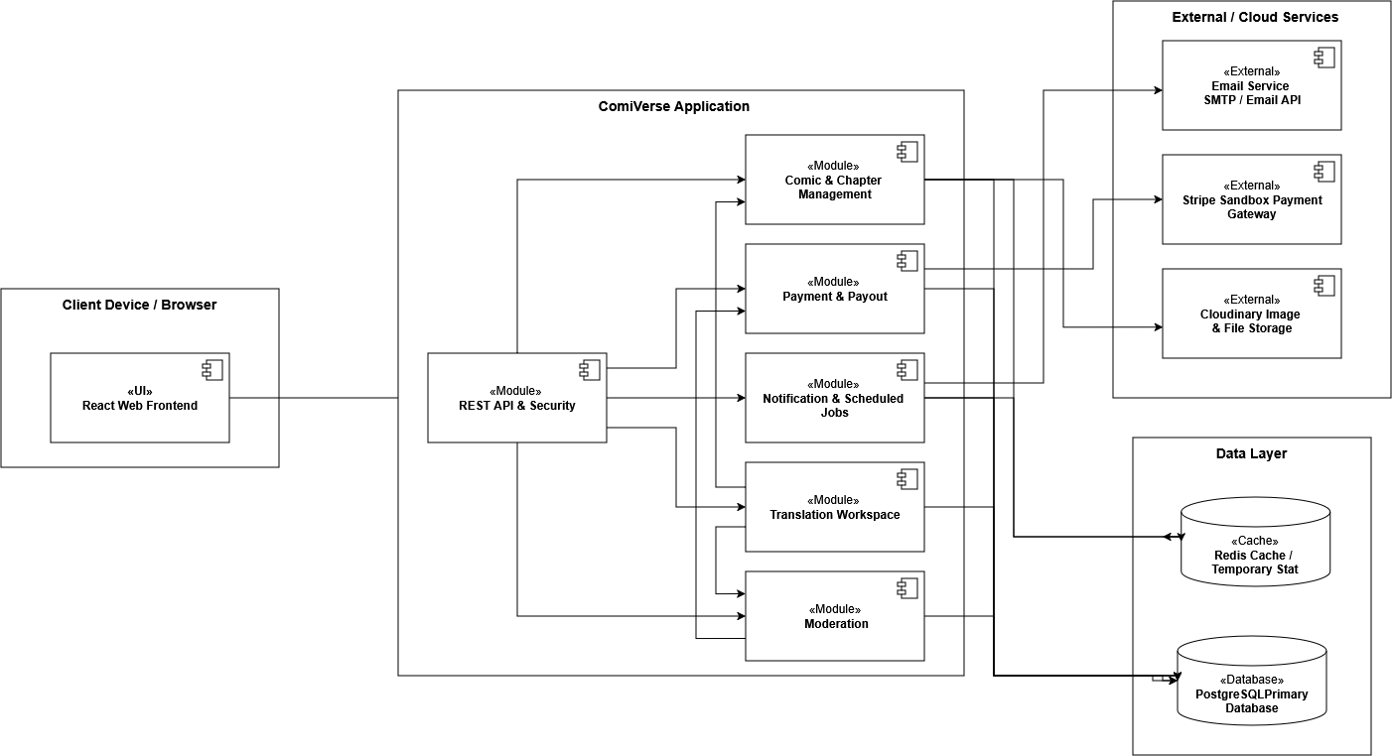

Component | Type | Responsibility | Technology
React Web Frontend | UI | Provides user interfaces for Readers, Authors, Translators, Moderators, and Administrators. Sends REST requests and receives real-time notifications from the backend. | React, Vite, JavaScript, HTML, CSS
REST API & Security | Module / Service | Acts as the main backend entry point. Handles REST endpoints, request validation, authentication, JWT verification, role-based authorization, and exception handling. | Java 21, Spring Boot 3.5, Spring Web, Spring Security, JWT, OAuth2
Comic & Chapter Management | Module / Service | Manages comics, chapters, genres, metadata, covers, chapter images, author publishing operations, public comic access, and publishing-right verification. | Spring Boot, Spring Data JPA, Hibernate, Cloudinary SDK
Translation Workspace | Module / Service | Manages translation projects, teams, chapter tasks, page translations, translation bubbles, task progress, handovers, and translator contribution records. | Spring Boot, Spring Data JPA, Hibernate
Moderation | Module / Service | Manages review queues, comic and chapter approval or rejection, translated-content review, reports, revocations, moderation history, and audit records. | Spring Boot, Spring Data JPA, Hibernate
Payment & Payout | Module / Service | Manages Premium subscriptions, Stripe payments, creator earnings, translator chapter settlements, author revenue, payout requests, and payment history. | Spring Boot, Stripe API, Spring Data JPA, Hibernate
Notification & Scheduled Jobs | Module / Service | Sends in-app, real-time, and email notifications. Executes scheduled jobs such as monthly settlement, subscription expiration checks, reminders, synchronization, and cleanup. | Spring Boot, Spring WebSocket, STOMP, Spring Scheduler, SMTP / Email API
PostgreSQL Primary Database | DB | Stores persistent relational data, including users, comics, chapters, translation tasks, moderation records, payments, settlements, licenses, and notifications. | PostgreSQL
Redis Cache | Cache / Temporary Store | Caches frequently accessed data and stores temporary runtime information such as view counters, rate-limit state, short-lived tokens, and notification state. | Redis
Cloudinary Image & File Storage | External / Cloud | Stores and delivers comic covers, chapter-page images, thumbnails, avatars, banners, and other uploaded media assets. | Cloudinary API
Stripe Sandbox Payment Gateway | External | Processes test subscription payments, checkout sessions, payment events, refunds, and payout-related operations. Sends payment updates through webhooks. | Stripe API, HTTPS Webhook
Email Service | External | Delivers verification emails, password-reset messages, moderation notifications, payment updates, and other transactional emails. | SMTP / Email API

1.3 Package / Module Diagram
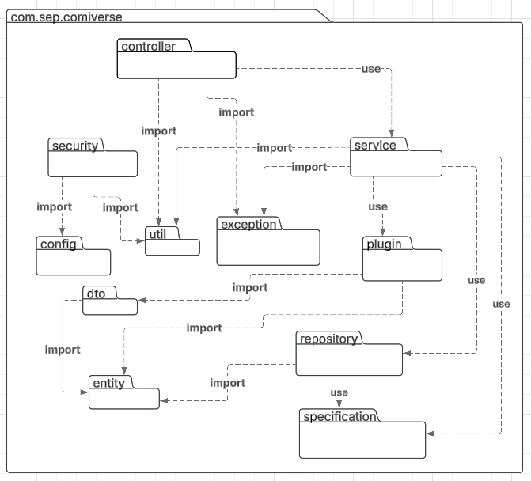

Package / Module | Layer | Responsibility | Allowed Dependencies
com.sep.comiverse.controller | Presentation | Exposes REST endpoints; handles requests and input validation (@Valid). Extends BaseController. | Can call: dto, plugin, service, exception  Cannot call: repository, entity
com.sep.comiverse.plugin | Business Logic | Orchestrates CRUD flows, transactions, and custom mapping hooks inheriting AbstractMapperPlugin. | Can call: repository, dto, entity, specification, exception  Called by: controller
com.sep.comiverse.service | Business Logic | Manages complex business rules, transaction boundaries (@Transactional), and external integration workflows. | Can call: repository, specification, dto, entity, exception, util  Called by: controller
com.sep.comiverse.repository | Data Access | Interacts with PostgreSQL, executes standard queries and pgvector Cosine Similarity searches inheriting AbstractCrudRepository. | Can call: entity  Called by: plugin, service
com.sep.comiverse.specification | Data Access | Dynamic JPA Criteria Specifications for catalog filtering and searching. | Can call: entity, dto  Called by: service
com.sep.comiverse.dto | Data Structure | Pure data structures for request payloads, API responses, and BaseResponse. | Can call: None  Used by: controller, plugin, service, repository
com.sep.comiverse.entity | Domain Model | Persistent database tables inheriting from BaseEntity (UUID v7 Primary Key). | Can call: None  Used by: repository, plugin, service, specification
com.sep.comiverse.security | Security | Secures REST endpoints statelessly using JWT (TokenAuthenticationFilter) and Spring Security RBAC. | Can call: config, dto, entity, repository, exception  Called by: Spring Security Filter Chain
com.sep.comiverse.config | Infrastructure | Spring configuration, security filter chain, ModelMapper, CORS, and OpenAPI beans. | Can call: security, plugin, service
com.sep.comiverse.exception | Cross-Cutting | Centralized exception handling (GlobalExceptionHandler) and custom domain exceptions. | Can call: dto  Used by: all layers
com.sep.comiverse.util | Cross-Cutting | Pure Java utility methods, environment helpers (Dotenv), and system constants. | Can call: None  Used by: all layers

1.4 Technology Stack
Layer | Technology | Version | Justification
Language | Java | 21 LTS | Team expertise; Virtual Threads optimize high-concurrency reading traffic.
Web Framework | Spring Boot | 3.5 | Core framework; provides native integration for spring-plugin-core.
ORM / Data Access | Spring Data JPA / Hibernate | 3.5 | Standard abstraction layer; interfaces cleanly with your custom repositories.
Primary Database | PostgreSQL + pgvector | 16+ | Robust ACID compliance; extension allows native Cosine Similarity queries.
Cache | None
Message Queue | None
Frontend | React | 18 | Fast, component-based rendering; ideal for seamless client-side reading.
Authentication | Spring Security + JWT | 3.5 | Secures REST endpoints statelessly; eliminates database session lookups.
Build Tool | Maven | 3.5 | Standard dependency management; matches typical Spring Plugin archetypes.
Test Framework | JUnit 5 + Mockito | 5.2 | Core testing suite; handles generic plugin logic validation through mocking.
Migration Tool | Flyway | 10.0 | Manages version-controlled schema evolution (critical for the pgvector setup).
Containerisation | Docker | Latest | Standardizes local multi-container development (App, Postgres, PgAdmin).
CI/CD | GitHub Actions |  | Automates compilation, testing pipelines, and Docker image builds.
Monitoring | Spring Boot Actuator | 3.5 | Built-in health metrics monitoring requires zero extra infrastructure.
Logging | SLF4J + Logback | Built-in | Default Spring logging framework; outputs structured file and console logs.

1.5 Deployment Architecture
Aspect | Development | Staging | Production
Infrastructure | Local Docker Compose (Laptop) | Railway (Shared Canvas/Project) | Railway (Dedicated Production Project)
Database | Local PostgreSQL Container + pgvector | Railway PostgreSQL (Shared resources) | Railway PostgreSQL (Dedicated Private Volume)
Scaling | Single instance | Single instance | Auto-scaling (Railway horizontal scaling via replicas)
External APIs | Cloudinary | Cloudinary | Cloudinary
Monitoring | Console Logs / Local Actuator | Railway Metrics Dashboard | Railway Metrics + Uptime Alerts (Webhooks/Slack)

Part 2 — Interface Specification

2.1 Interface Inventory & Classification
Feature | Feature Name | Interface Type | Reason for Choice
FT-01 | User Authentication & Access | REST API + Internal Service | The React application submits registration, login, email verification, logout, and password-recovery requests to /api/auth/**. Spring Security handles Google OAuth2 redirects, while the authentication service calls Resend to deliver verification and recovery messages.
FT-02 | Account Settings & Assets | REST API + Internal Service | Authenticated profile and password operations use /api/auth/me, /api/auth/profile, and /api/auth/change-password. Account information is processed through internal user and authentication services.
FT-03 | Comic Submission Pipeline | REST API + Internal Service | Author operations use /api/author/comics/**. Multipart ZIP/CBZ packages are validated by backend services, and extracted comic images are uploaded to Cloudinary.
FT-04 | Content Moderation Gate | REST API + Internal Service | Moderator and Admin review operations use /api/submissions/**. Approval and rejection invoke service-layer state transitions and audit processing.
FT-05 | Translator Onboarding | REST API + Internal Service | Team creation, applications, invitations, membership, and member-management operations use /api/project-teams/** and /api/team-workspace/**.
FT-06 | Translation & Localization Portal | REST API + Internal Service | Translation pools, project claims, announcements, requests, assignments, and workspace operations use /api/translation-pool/** and /api/team-workspace/**.
FT-07 | Chapter Production Tracker | REST API + Internal Service | Chapter tasks and workflow statuses are managed through translation-task and team-workspace endpoints. The React application presents the task workflow as list or Kanban views.
FT-08 | Creator Cloud Studio | REST API + Internal Service | Translation pages and text bubbles use /api/translate-workspace/{taskId} and /api/translate-workspace/pages/{pageId}/bubbles. Canvas rendering and text-bubble positioning are handled by React.
FT-09 | Search & Recommendation Engine | REST API + Internal Service + Scheduled Job | Public catalog operations use /api/comics/**. Scheduled jobs calculate leaderboards, comic embeddings, and user preference vectors and cache results using Redis and PostgreSQL.
FT-10 | Comic Reader & Version Switcher | REST API + Internal Service | Chapter metadata, available versions, and page URLs are retrieved through /api/chapters/**. Reading direction, zoom, and version selection are handled by the React interface.
FT-11 | Cross-Platform Progress Sync | REST API + Internal Service + Scheduled Job | /api/reading-histories/** and /api/saves/** expose reading progress and bookmark data. Scheduled jobs synchronize temporary Redis data with PostgreSQL.
FT-12 | User Engagement & Ranking System | REST API + Internal Service + Scheduled Job | Likes use /api/likes/**, while ratings and comments require REST resources. Ranking information is periodically calculated and cached. Rating and comment functions remain partially implemented.
FT-13 | Community Forums & Messaging | REST API + Internal Service | Forum threads use /api/forum-threads/**, while translation-team messages use /api/team-workspace/{teamId}/messages. Current messaging uses REST requests instead of WebSocket communication.
FT-14 | Notification & User Center | REST API + Internal Service | Admin broadcasts use /api/admin/broadcasts/**. Users retrieve and acknowledge notifications through /api/notifications/**.
FT-15 | Policy & Content Audit | REST API + Internal Service | Submission reviews, forum moderation, chat flags, reports, and audit-log operations use synchronous REST interfaces and internal moderation services.
FT-16 | Monetization & Token Management | REST API + Internal Service | /api/plans exposes premium-plan settings and the current upgrade operation. A production payment gateway, webhook receiver, wallet ledger, and payout workflow are not yet fully implemented.
FT-17 | Analytics & Dashboards | REST API + Internal Service + Scheduled Job | Author metrics use /api/author/comics/{comicId}/metrics. Scheduled jobs aggregate Redis and PostgreSQL activity data for statistics and leaderboards.
FT-18 | Global Admin Control Panel | REST API + Internal Service | Admin endpoints manage users, comics, genres, premium settings, broadcasts, audit data, and system configuration.

2.1.1 Scheduled Interface Inventory

Scheduled Contract | Trigger | Responsibility | Related Feature(s)
ViewSyncScheduler.flushViewsToPostgres() | Every 5 minutes | Flush comic and chapter view counters and reading-history data from Redis to PostgreSQL. | FT-11, FT-17
ViewSyncScheduler.cleanOldReadingHistories() | Daily at 00:00 | Remove obsolete reading-history records while retaining the latest applicable record. | FT-11
UserInteractionSyncScheduler.flushInteractionsToPostgres() | Every hour | Persist like and save counter changes maintained in Redis. | FT-11, FT-12
LeaderboardScheduler.computeLeaderboards() | Every 15 minutes | Calculate daily, weekly, and monthly ranking data and cache the results. | FT-09, FT-12, FT-17
RecommendationScheduler.processNewComicsEmbeddings() | Hourly at minute 0 | Generate missing comic embeddings through Gemini and persist vector values. | FT-09
RecommendationScheduler.processUserPreferences() | Hourly at minute 30 | Recalculate user preference vectors from recorded user interactions. | FT-09
No Event/Message interface is currently implemented. All module-to-module operations are synchronous method calls within the Spring Boot application.

2.2 Authentication & Session / Token Design
ComiVerse uses stateless JWT authentication because the React SPA communicates with the backend through REST APIs. Local login and Google OAuth2 login produce the same JWT and Spring Security authority model.
The backend uses SessionCreationPolicy.STATELESS and does not create an application session using JSESSIONID.

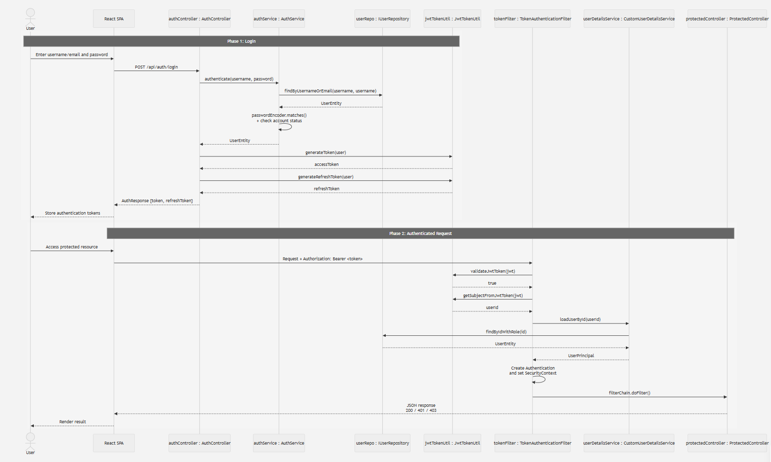

JWT-Based Auth
Aspect | Design Decision
Token format | JWT signed using HS256 through JJWT. The signing secret is loaded from the backend JWT_SECRET environment variable.
Access token expiry | 24 hours (86,400,000 milliseconds), configured through app.auth.tokenExpirationMs.
Refresh token expiry | 7 days.
Token storage (client) | The React application currently stores the access token and refresh token in browser localStorage. This is simple to implement but exposes tokens if an XSS attack succeeds. The production target is to store the refresh token in a Secure, HttpOnly, SameSite=Lax cookie.
Token blacklist strategy | No blacklist or token-revocation store is currently implemented. Logout deletes tokens from the browser, but issued JWTs remain valid until expiration. Redis-based token revocation or a token-version field should be implemented before production.
Claims included | sub — user UUID; role — global system role; iat — token issue time; exp — token expiration time. Translation-team roles are loaded from the database and are not included in the global JWT.

2.3 REST API Endpoints
ComiVerse is a React SPA that communicates with the Spring Boot backend primarily through REST APIs. Because the system contains more than ten REST endpoints, the complete endpoint specification is maintained in the OpenAPI/Swagger documentation. This section defines the common API conventions and provides a representative endpoint contract.

API Conventions
Convention | Decision
Base URL | /api
Versioning Strategy | No explicit API version is currently included in the URL path
Default Content Type | application/json
File Upload Content Type | multipart/form-data
Authentication | Protected endpoints require Authorization: Bearer {accessToken}
Token Type | JWT
Date/Time Format | ISO 8601 UTC, for example 2026-07-17T14:30:00Z
Pagination | Page-based pagination using query parameters such as page and size where applicable
Success Response | {"success":true,"data":...,"message":"..."}
Error Response | {"error_code":"...","message":"...","field":"..."}
Correlation Header | X-Correlation-ID may be used to associate requests with application logs
OpenAPI Specification | ComiVerse_OpenAPI.yaml
Runtime OpenAPI | /api/v3/api-docs
Swagger UI | /api/swagger-ui.html

Representative Endpoint — POST /api/auth/login

Endpoint Information
Attribute | Value
Purpose | Authenticate a user with a registered username/email and password
Related SRS Feature | FT-01 — User Authentication & Access
Authorization | Public

Request Headers
Attribute | Value
Content-Type | Must be application/json
Accept | Indicates that the client expects a JSON response
X-Correlation-ID | Identifier used to associate the request with related application logs

Path Parameters
Attribute | Value
None | No path parameters are required.

Query Parameters
Attribute | Value
None | No query parameters are required.

Endpoint Information
Attribute | Value
usernameOrEmail | String
password | String

Response
HTTP Status | Condition | Response Body
200 OK | Credentials are valid and the account is active. | {"success":true,"data":{"accessToken":"string","refreshToken":"string","user":"object"},"message":"Login successful"}
400 Bad Request | A required field is missing or invalid. | {"error_code":"VAL_001","message":"Request validation failed","field":"usernameOrEmail"}
401 Unauthorized | Username/email or password is invalid. | {"error_code":"AUTH_001","message":"Invalid credentials","field":null}
403 Forbidden | The account is blocked, inactive, or pending verification. | {"error_code":"AUTH_002","message":"Account is not permitted to sign in","field":null}
429 Too Many Requests | The login request limit is exceeded. | {"error_code":"AUTH_429","message":"Too many login attempts","field":null}
500 Internal Server Error | An unexpected authentication service error occurs. | {"error_code":"SYS_001","message":"Contact support","field":null}

2.4 Internal Service Interfaces
Internal Service Interface Template (Java)
// [ServiceName] — one-sentence responsibility
public interface [ServiceName] {

/**
* [Method description — what it does, when to call it]
* @param [param] [description + constraints]
* @return [return type + description]
* @throws [ExceptionType] [when thrown — reference BR-xx or DC-xx]
*/
[ReturnType] [methodName]([ParamType] [param]);

// Add all key public methods
}

ComiVerse is implemented as a layered Spring Boot monolith. Controllers call internal service contracts through direct in-process method calls. Services enforce business rules and communicate with repositories or external integration adapters.
Controllers must not access repositories directly. The following interfaces define the main contracts between the controller, service, and persistence layers.

2.4.1 Authentication Service
// AuthService — manages authentication, verification, password, and profile operations.
public interface AuthService {

/**
* Authenticates a user using a username/email and password.
*
* @param request validated login credentials
* @return JWT tokens and safe account information
* @throws AuthenticationException when credentials are invalid
* @throws AccountStatusException when the account cannot sign in
* (BR-01, BR-03)
*/
AuthResponse authenticate(AuthRequest request);

/**
* Registers a new local account and sends a verification OTP.
*
* @param request validated registration information
* @return the newly created account information
* @throws ConflictException when the username or email already exists
* (BR-02, BR-04)
*/
UserResponse register(RegisterRequest request);

/**
* Verifies a newly registered account using a single-use OTP.
*
* @param request email and verification OTP
* @throws ValidationException when the OTP is invalid or expired
* (BR-04, BR-05)
*/
void verifyEmail(VerifyEmailRequest request);

/**
* Starts the password-recovery process.
*
* @param email account email address
*/
void forgotPassword(String email);

/**
* Resets a local account password using a valid recovery OTP.
*
* @param request email, OTP, and new password
* @throws ValidationException when the OTP is invalid or expired
*/
void resetPassword(ResetPasswordRequest request);

/**
* Updates the authenticated user's profile.
*
* @param userId authenticated user UUID
* @param request validated profile information
* @return updated profile information
*/
UserProfileResponse updateProfile(
UUID userId,
UpdateProfileRequest request
);
}

2.4.2 Author Comic Service
// AuthorComicService — manages author-owned comics and ownership validation.
public interface AuthorComicService {

/**
* Creates a new comic owned by the authenticated author.
*
* @param authorId authenticated author UUID
* @param request validated comic information
* @return the created comic
* @throws ForbiddenException when the user is not an Author
* @throws ConflictException when comic data violates a uniqueness rule
* (BR-11, BR-13)
*/
ComicResponse createComic(
UUID authorId,
CreateComicRequest request
);

/**
* Returns comics owned by the authenticated author.
*
* @param authorId authenticated author UUID
* @param page zero-based page number
* @param size requested page size
* @return paginated author-owned comics
*/
PageResponse<ComicResponse> listOwnComics(
UUID authorId,
int page,
int size
);

/**
* Updates an author-owned comic.
*
* @param authorId authenticated author UUID
* @param comicId comic UUID
* @param request validated update information
* @return the updated comic
* @throws ResourceNotFoundException when the comic does not exist
* @throws ForbiddenException when the author does not own the comic
* (BR-12)
*/
ComicResponse updateComic(
UUID authorId,
UUID comicId,
UpdateComicRequest request
);

/**
* Submits an author-owned comic for moderation.
*
* @param authorId authenticated author UUID
* @param comicId comic UUID
* @throws ConflictException when the comic is not in a submittable state
* (BR-14, BR-15)
*/
void submitForReview(UUID authorId, UUID comicId);
}

2.4.3 Author Chapter Service
// AuthorChapterService — manages uploaded chapter packages and submission states.
public interface AuthorChapterService {

/**
* Uploads and validates a ZIP/CBZ chapter package.
*
* @param authorId authenticated author UUID
* @param comicId target comic UUID
* @param file uploaded ZIP or CBZ file
* @return the created chapter information
* @throws ForbiddenException when the author does not own the comic
* @throws FileValidationException when the archive type, size,
* or contents are invalid
*/
ChapterResponse uploadChapterZip(
UUID authorId,
UUID comicId,
MultipartFile file
);

/**
* Returns a preview of an uploaded chapter.
*
* @param authorId authenticated author UUID
* @param chapterId chapter UUID
* @return chapter metadata and ordered page information
* @throws ResourceNotFoundException when the chapter does not exist
* @throws ForbiddenException when the author does not own the chapter
*/
ChapterPreviewResponse previewChapter(
UUID authorId,
UUID chapterId
);

/**
* Submits a chapter to the moderation queue.
*
* @param authorId authenticated author UUID
* @param chapterId chapter UUID
* @throws ConflictException when the chapter cannot enter review
* (BR-16, BR-17)
*/
void submitForReview(UUID authorId, UUID chapterId);

/**
* Deletes a chapter owned by the authenticated author.
*
* @param authorId authenticated author UUID
* @param chapterId chapter UUID
* @throws ForbiddenException when the author does not own the chapter
*/
void deleteChapter(UUID authorId, UUID chapterId);
}

2.4.4 Translation Team Service
// TranslationTeamService — manages translation teams, members, and team roles.
public interface TranslationTeamService {

/**
* Creates a translation team owned by the authenticated translator.
*
* @param ownerId authenticated translator UUID
* @param request validated team information
* @return the created translation team
* @throws ConflictException when the user already owns a conflicting team
* (BR-21, BR-22)
*/
TranslationTeamResponse createTeam(
UUID ownerId,
CreateTeamRequest request
);

/**
* Adds an approved translator to a team.
*
* @param actorId requesting Group Owner or Group Manager UUID
* @param teamId translation team UUID
* @param userId translator UUID
* @param role requested team-level role
* @return the created membership
* @throws ForbiddenException when the actor lacks team permission
* @throws ConflictException when the translator is already a member
* (BR-23, BR-24, BR-25)
*/
TeamMemberResponse addMember(
UUID actorId,
UUID teamId,
UUID userId,
TeamRole role
);

/**
* Removes a translator from a team.
*
* @param actorId requesting Group Owner or Group Manager UUID
* @param teamId translation team UUID
* @param memberId membership UUID
* @throws ForbiddenException when the actor lacks permission
*/
void removeMember(
UUID actorId,
UUID teamId,
UUID memberId
);

/**
* Returns all members of a translation team.
*
* @param requesterId authenticated requester UUID
* @param teamId translation team UUID
* @return team-member information
* @throws ForbiddenException when the requester cannot view the team
*/
List<TeamMemberResponse> getTeamMembers(
UUID requesterId,
UUID teamId
);
}

2.4.5 Translation Task Service
// TranslationTaskService — manages chapter-production tasks and workflow transitions.
public interface TranslationTaskService {

/**
* Creates a new translation task within a project.
*
* @param actorId authorized team leader or manager UUID
* @param projectId translation project UUID
* @param request validated task information
* @return the created task
* @throws ForbiddenException when the actor lacks project permission
* @throws ConflictException when task data violates workflow rules
* (BR-31, BR-32)
*/
TranslationTaskResponse createTask(
UUID actorId,
UUID projectId,
CreateTaskRequest request
);

/**
* Assigns a translation task to a team member.
*
* @param actorId authorized team leader or manager UUID
* @param taskId translation task UUID
* @param assigneeId assigned member UUID
* @return the updated task
* @throws ForbiddenException when the actor lacks permission
* @throws ValidationException when the assignee is not a project member
* (BR-33)
*/
TranslationTaskResponse assignTask(
UUID actorId,
UUID taskId,
UUID assigneeId
);

/**
* Changes a task to a permitted workflow status.
*
* @param actorId authenticated project member UUID
* @param taskId translation task UUID
* @param status requested workflow status
* @return the updated task
* @throws ConflictException when the status transition is invalid
* (BR-34, BR-35)
*/
TranslationTaskResponse updateStatus(
UUID actorId,
UUID taskId,
TaskStatus status
);

/**
* Returns tasks for the project Kanban board.
*
* @param requesterId authenticated project member UUID
* @param projectId translation project UUID
* @return tasks grouped or ordered by workflow status
*/
List<TranslationTaskResponse> getProjectTasks(
UUID requesterId,
UUID projectId
);
}

Part 3 — Data Model

3.1 Physical Entity Relationship Diagram 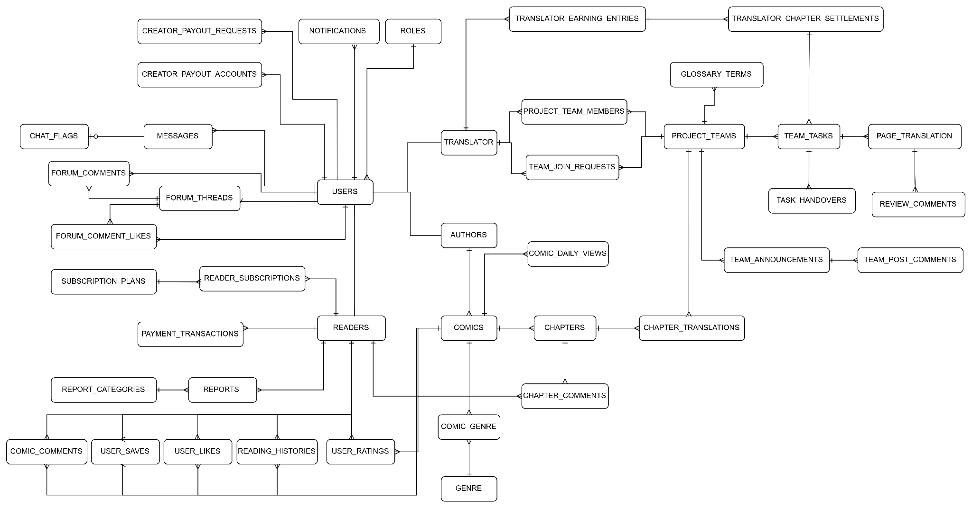

3.2 Database Schema (DDL)
ComiVerse uses PostgreSQL as its primary relational database and enables the pgvector extension to support vector-based semantic search and recommendation features.
The database schema follows the project's physical entity model. UUID values are used as primary keys for core entities, while foreign-key constraints maintain relationships between users, roles, comics, and chapters. Logical deletion is implemented through the deleted flag to preserve historical references without physically removing records.
Frequently queried columns and combinations are indexed to improve authentication, comic discovery, author management, chapter retrieval, and moderation operations.
The following DDL represents the current core database schema of ComiVerse.

-- Enable pgvector extension for semantic search
CREATE EXTENSION IF NOT EXISTS vector;

-- =========================================================
-- ROLES
-- Stores system roles used for Role-Based Access Control.
-- SRS Reference: UserRole Entity
-- =========================================================

CREATE TABLE roles (
id UUID PRIMARY KEY,
role_name VARCHAR(50) NOT NULL UNIQUE,
deleted BOOLEAN DEFAULT FALSE,
create_at TIMESTAMPTZ NOT NULL DEFAULT NOW(),
update_at TIMESTAMPTZ NOT NULL DEFAULT NOW()
);

-- =========================================================
-- USERS
-- Stores account and profile information for users,
-- authors, translators, moderators, and administrators.
-- SRS Reference: User Account, DC-01, DC-02
-- =========================================================

CREATE TABLE users (
id UUID PRIMARY KEY,
username VARCHAR(255) UNIQUE,
password VARCHAR(255),
full_name VARCHAR(255),
email VARCHAR(255) NOT NULL UNIQUE,
phone VARCHAR(50),

role_id UUID
REFERENCES roles(id)
ON DELETE RESTRICT,

provider VARCHAR(50) NOT NULL DEFAULT 'LOCAL',
provider_id VARCHAR(255),

avatar_url VARCHAR(500),
background_image_url VARCHAR(500),

reset_token VARCHAR(255),
reset_token_expires_at TIMESTAMPTZ,

email_verification_token VARCHAR(255),
email_verification_expires_at TIMESTAMPTZ,

assigned_languages VARCHAR(255),

premium_plan VARCHAR(50),
premium_expires_at TIMESTAMPTZ,

status VARCHAR(50) NOT NULL DEFAULT 'ACTIVE',

date_of_birth DATE,
bio TEXT,

user_vector vector(768),
vector_updated_at TIMESTAMPTZ,

last_seen_at TIMESTAMPTZ,

deleted BOOLEAN DEFAULT FALSE,

create_at TIMESTAMPTZ NOT NULL DEFAULT NOW(),
update_at TIMESTAMPTZ NOT NULL DEFAULT NOW()
);

-- Indexes
-- Support user lookup, authentication, and profile searching.

CREATE INDEX idx_users_email
ON users(email);

CREATE INDEX idx_users_full_name
ON users(full_name);

CREATE INDEX idx_users_username
ON users(username);

-- =========================================================
-- COMICS
-- Stores the main metadata and moderation state
-- of each comic series.
-- SRS Reference: Comic Entity, DC-11
-- =========================================================

CREATE TABLE comics (
id UUID PRIMARY KEY,

title VARCHAR(255) NOT NULL,
summary TEXT,

language VARCHAR(100) NOT NULL DEFAULT 'Unknown',
minimum_age INTEGER,

author_id UUID
REFERENCES users(id)
ON DELETE RESTRICT,

publication_status VARCHAR(50),

moderation_status VARCHAR(32) NOT NULL DEFAULT 'DRAFT',

is_appealed BOOLEAN NOT NULL DEFAULT FALSE,
is_mod_edited BOOLEAN NOT NULL DEFAULT FALSE,

previous_state_snapshot TEXT,
appeal_reason TEXT,
rejection_reason TEXT,

cover VARCHAR(500),

view_count BIGINT NOT NULL DEFAULT 0
CHECK (view_count >= 0),

save_count INTEGER NOT NULL DEFAULT 0
CHECK (save_count >= 0),

like_count INTEGER NOT NULL DEFAULT 0
CHECK (like_count >= 0),

rating_average DOUBLE PRECISION NOT NULL DEFAULT 0.0
CHECK (
rating_average >= 0.0
AND rating_average <= 5.0
),

rating_count INTEGER NOT NULL DEFAULT 0
CHECK (rating_count >= 0),

latest_chapter_number VARCHAR(50),
latest_chapter_update_at TIMESTAMPTZ,

chapter_count INTEGER NOT NULL DEFAULT 0
CHECK (chapter_count >= 0),

summary_vector vector(768),

approved_by_id UUID
REFERENCES users(id)
ON DELETE RESTRICT,

approved_at TIMESTAMPTZ,

deleted BOOLEAN DEFAULT FALSE,

create_at TIMESTAMPTZ NOT NULL DEFAULT NOW(),
update_at TIMESTAMPTZ NOT NULL DEFAULT NOW()
);

-- Indexes
-- Support comic visibility, moderation queues,
-- and author-owned comic queries.

CREATE INDEX idx_comics_moderation_deleted
ON comics(moderation_status, deleted);

CREATE INDEX idx_comics_author_deleted
ON comics(author_id, deleted);

-- =========================================================
-- CHAPTERS
-- Stores chapters belonging to comic series.
-- SRS Reference: Chapter Entity, DC-12
-- =========================================================

CREATE TABLE chapters (
id UUID PRIMARY KEY,

comic_id UUID NOT NULL
REFERENCES comics(id)
ON DELETE RESTRICT,

chapter_number VARCHAR(50) NOT NULL DEFAULT '1',
title VARCHAR(255),

moderation_status VARCHAR(32) NOT NULL DEFAULT 'PREVIEW_READY',

rejection_reason TEXT,

images TEXT[] NOT NULL,

view_count BIGINT NOT NULL DEFAULT 0
CHECK (view_count >= 0),

is_premium BOOLEAN NOT NULL DEFAULT FALSE,

approved_by_id UUID
REFERENCES users(id)
ON DELETE RESTRICT,
approved_at TIMESTAMPTZ,

rejected_by_id UUID
REFERENCES users(id)
ON DELETE RESTRICT,

content_hash VARCHAR(64),

deleted BOOLEAN DEFAULT FALSE,

create_at TIMESTAMPTZ NOT NULL DEFAULT NOW(),
update_at TIMESTAMPTZ NOT NULL DEFAULT NOW()
);

-- Indexes
-- Support chapter lookup and moderation processing.

CREATE INDEX idx_chapters_comic_number_deleted
ON chapters(comic_id, chapter_number, deleted);

CREATE INDEX idx_chapters_moderation_deleted
ON chapters(moderation_status, deleted);

-- =========================================================
-- COMIC_GENRE
-- Junction table representing the many-to-many relationship
-- between comics and genres.
-- =========================================================

CREATE TABLE comic_genre (
comic_id UUID NOT NULL
REFERENCES comics(id)
ON DELETE CASCADE,

genre_id UUID NOT NULL,

PRIMARY KEY (comic_id, genre_id)
);

3.3 ORM / ODM Entity Mapping
ORM Entity (JPA / Spring)
@Entity
@Table(name = "chapters")
public class ChapterEntity extends BaseEntity {

@Column(name = "chapter_number", nullable = false)
private String chapterNumber = "1";

@Column(name = "title")
private String title;

@Enumerated(EnumType.STRING)
@Column(name = "moderation_status", nullable = false, length = 32)
private ChapterStatus moderationStatus = ChapterStatus.PREVIEW_READY;

// Many-to-One: FetchType.LAZY is explicitly set to prevent N+1 queries
// when loading large lists of chapters.
@ManyToOne(fetch = FetchType.LAZY)
@JoinColumn(name = "comic_id")
private ComicEntity comic;

// Using PostgreSQL ARRAY instead of OneToMany mapping for performance on image lists
@JdbcTypeCode(SqlTypes.ARRAY)
@Column(name = "images", nullable = false)
private List<String> images = new ArrayList<>();
}

Fetch Strategy & Cascade Table

Entity | Fetch Strategy | Cascade | Reason
Chapter → Comic | LAZY | NONE | Chapter loads comic on-demand (e.g. details page). Comic has independent lifecycle.
Comic → Genre | LAZY | NONE | Prevents Cartesian product on home page. Genres are static reference data.
Report → User | LAZY | NONE | Mod dashboard only needs User IDs mostly. Loading full User entities causes unnecessary overhead.

3.4 Indexing & Query Strategy
Index Table

Index | Table | Column(s) | Query Pattern | Cardinality | Notes
idx_users_email | users | email | Used during login and OAuth2 matching. | High | Essential for Auth.
idx_users_username | users | username | Used for profile lookups and mentions. | High | Must be unique.
idx_comics_mod_deleted | comics | moderation_status, deleted | Filter PENDING comics for Moderator Review Queue. | Medium | Critical for Mod Dashboard.
idx_comics_author_deleted | comics | author_id, deleted | Fetching an author's comic library. | Medium | Optimizes Author Dashboard.
idx_chapters_comic_num | chapters | comic_id, chapter_number, deleted | Fetch chapters sequentially for Comic Detail page. | High | Prevents full-table scans.
idx_submissions_queue | submissions | queue_type, status, deleted | Queue filtering by category (Comic/Chapter/Team). | Medium | Mod submission queue.
idx_reports_status | reports | status, deleted | Fetching unresolved reports for action. | Medium | Speeds up report management.
idx_team_tasks_project_st | team_tasks | project_team_id, status | Listing active vs completed tasks per team. | Medium | Translator Workspace API.
idx_payment_user | payment_transactions | user_id, create_at | Loading billing history for users. | High | Finance/Billing pages.
idx_payment_status | payment_transactions | status, create_at | Admin revenue dashboard (successful vs failed). | Medium | Admin Statistics.
idx_offline_pkg_user | offline_packages | user_id, create_at | Listing downloaded DRM packages per user. | High | Offline Reader feature.
idx_offline_device_user | offline_devices | user_id, revoked, deleted | Checking active offline devices limit per user. | Low-Med | DRM Device Enrollment.
idx_creator_payout_user | creator_payout_requests | user_id, create_at | Tracking withdrawal history for creators. | High | Creator earnings page.
idx_sub_plan_stripe | subscription_plans | stripe_price_id | Webhook matching Stripe ID to internal Plan. | High | Stripe Webhook Controller.

N+1 Risk and Mitigation Table

Query | N+1 Risk | Mitigation
Home/Explore: List of comics with Genres | N+1 on comic_genre bridging table (1 query per comic to get genres) | Add @EntityGraph(attributePaths = {"genres"}) to the Spring Data JPA Repository method.
Reader: Chapter Details fetching Parent Comic | N+1 on comics table (Fetching chapter details loads comic implicitly if accessed) | Use custom JPQL with JOIN FETCH ch.comic c.
Moderator: Report List with Target Details | N+1 on target Entities (Comic/Chapter/Comment depending on target_type) | Use Spring Data Projections (DTO Interfaces) directly in the Repository to bypass Entity hydration.
Translator: Project Team listing Members | N+1 on users table via team_members bridging table | Use JOIN FETCH pt.members when loading a team workspace.
Admin: Payout Request List | N+1 on users and creator_payout_accounts | Use @EntityGraph mapping to load the requesting User and their Stripe Account info in 1 query.
Submission Queue: Listing Submissions | N+1 on users (author) and comics | Custom JPQL: SELECT s FROM SubmissionEntity s JOIN FETCH s.author JOIN FETCH s.comic.

Part 4 — Integration & Communication Design

4.1 External System Integration Map
External System | Direction | Protocol | Auth Method | Sync/Async | Error Handling | SRS Ref
Google OAuth2 / Google Sign-In | Outbound + Callback | HTTPS / OAuth2 | OAuth2 Authorization Code for web; Google ID Token verification for mobile | Sync | Invalid authorization or ID token is rejected; login returns authentication failure | FT-01
Gmail SMTP | Outbound | SMTP + STARTTLS | SMTP username + App Password | Sync | SMTP delivery failures are logged; configuration or message construction failures return service errors | FT-01, FT-14
SendGrid | Outbound | HTTPS / API | API Key | Sync | API or delivery failures are logged and converted to email service errors | FT-01, FT-14
Cloudinary | Outbound | HTTPS through Cloudinary SDK | Cloud Name + API Key + API Secret | Sync API call; may execute inside background upload job | Upload failure terminates the upload operation; asynchronous chapter upload task is marked failed | FT-02, FT-03
Gemini API | Outbound | HTTPS / REST | API Key | Sync API call; also invoked by scheduled jobs | OCR failures are logged and returned as processing errors; embedding failures are logged and may be retried by a later scheduled job | FT-06, FT-08, FT-09
Firebase Cloud Messaging | Outbound | HTTPS through Firebase Admin SDK | Google Service Account / Application Default Credentials | Async | Push failures are logged and do not rollback committed in-app notifications; invalid device tokens are removed | FT-14
Stripe Payment & Connect | Outbound + Inbound Webhook | HTTPS / REST | Stripe Test Secret Key + Webhook Signature | Both | API errors are mapped to gateway errors; webhook signature is validated; event IDs prevent duplicate processing; Stripe may retry failed webhook deliveries | FT-16

4.2 Webhook Handling Design
- Webhook handling is not implemented in the current ComiVerse system.
- The current implementation does not expose an inbound webhook receiver for external services. Payment-related operations are currently handled without a production payment gateway webhook flow.

Aspect | Design Decision
Implementation Status | Implemented
Webhook Provider | Stripe
Direction | Inbound
Endpoint | POST /api/stripe/webhook
Payload | Raw JSON request body
Signature Verification | Stripe webhook signature verification
Signature Header | Stripe-Signature
Timestamp Tolerance | 300 seconds
Normal JWT Required | No
Idempotency Mechanism | Stripe event ID is persisted; duplicate event IDs are ignored
Database Uniqueness | Unique constraint on Stripe event_id
Processing | Deduplicate event → update payment → update subscription → persist webhook event
Successful Response | HTTP 200 after successful processing

4.3 Synchronous External API Integration

4.3.1 Google OAuth2 / Google Sign-In — User Authentication

Aspect | Detail
External System | Google Identity
Web Authentication | OAuth2 Authorization Code through Spring Security
Mobile Authentication | Google ID Token verification
Application Endpoint — Web | /api/oauth2/authorization/google
OAuth Callback | /api/login/oauth2/code/google
Application Endpoint — Mobile | POST /api/auth/google-login
Google Verification Endpoint | https://oauth2.googleapis.com/tokeninfo?id_token=...
Authentication | Google OAuth client ID/client secret for web; Google ID Token for mobile
Payload | OAuth authorization parameters or { "idToken": "..." }
Triggered by | FT-01 — Login / Register with Google
Timeout | No explicit Google-specific timeout configured
Retry Policy | No application-level automatic retry
Circuit Breaker | None
Failure Handling | Invalid OAuth flow or ID token results in authentication failure / HTTP 401
Fallback | User may use normal username/password authentication

4.3.2. Email Provider — Account Verification and Password Recovery

Gmail SMTP — Default Provider

Aspect | Detail
Host | smtp.gmail.com
Port | 587
Protocol | SMTP with STARTTLS
Authentication | SMTP username + App Password
Triggered by | Account verification, password reset, authentication-related emails
Connection Timeout | 10 seconds
Read Timeout | 10 seconds
Write Timeout | 10 seconds
Retry Policy | No explicit automatic retry
Circuit Breaker | None
Failure Handling | SMTP failures are logged; configuration/message errors return service errors

SendGrid

Aspect | Detail
Provider | SendGrid
Integration | sendgrid-java
Protocol | HTTPS / API
Authentication | SendGrid API Key
Payload Format | Email message payload
Triggered by | Account verification, password recovery, and system email delivery
Retry Policy | No application-level retry specified in the provided analysis
Circuit Breaker | None specified
Failure Handling | Provider/API delivery failures are logged and returned as email service errors

4.3.3. Cloudinary — Comic Asset Storage

Aspect | Detail
Integration | Cloudinary Java SDK
Authentication | Cloud Name + API Key + API Secret
Configuration | Environment variables
Triggered by | Avatar upload, comic image upload, chapter image upload, raw file upload
Payload | Image/file binary data
Response | Secure Cloudinary URL
Timeout | No application-specific timeout configured
Retry Policy | No explicit automatic retry
Circuit Breaker | None
Failure Handling | Upload operation fails and exception is propagated
Background Upload Behavior | Chapter upload task is marked failed when Cloudinary processing fails
Fallback | No alternate storage provider

4.3.4. Gemini API — OCR and Recommendation Embeddings

Aspect | Detail
Base URL | https://generativelanguage.googleapis.com/v1beta/models/
OCR Operation | {model}:generateContent
Recommendation Operation | gemini-embedding-001:embedContent
Authentication | API key in request query parameter
Request Format | JSON
Triggered by | Translation/OCR workflow and recommendation vector generation
Related Feature | FT-06, FT-08, FT-09
Timeout | No explicit Gemini-specific timeout configured
Retry Policy | No immediate application-level retry
Scheduled Retry Behavior | Comics missing embeddings may be processed again during a later scheduled job
Circuit Breaker | None
OCR Failure | Logged and returned as processing failure

4.3.5. Firebase Cloud Messaging — Push Notifications

Aspect | Detail
Provider | Firebase Cloud Messaging
Client Library | Firebase Admin SDK
Authentication | Firebase service account or Google Application Default Credentials
Enabled By | FIREBASE_PUSH_ENABLED=true
Triggered By | Committed in-app notification
Communication Mode | Async
Payload | Notification ID, title, body, type, action URL, created time
Batch Size | Maximum 500 device messages per batch
Retry Policy | No explicit application retry
Circuit Breaker | None
Failure Handling | Failure is logged and does not rollback original in-app notification
Invalid Token Handling | Tokens reported as UNREGISTERED are removed

4.3.6. Stripe Payment & Connect — Subscription and Creator Payout

Aspect | Detail
Base URL | https://api.stripe.com/v1
Sandbox Mode | Stripe API using test-mode credentials
Authentication | Authorization: Bearer <STRIPE_SECRET_KEY>
Required Key Mode | Test key beginning with sk_test_
Outbound Request Format | application/x-www-form-urlencoded
Inbound Webhook Format | JSON
Webhook Endpoint | POST /api/stripe/webhook
Webhook Authentication | Stripe-Signature + webhook secret
Triggered By | Subscription checkout, billing portal, Stripe Connect onboarding, creator payout, Stripe webhook event
Timeout | No explicit Stripe-specific timeout configured
Retry Policy | No application-level outbound HTTP retry
Circuit Breaker | None
Idempotency — Outbound | Stripe Idempotency-Key supplied for supported write operations
Idempotency — Webhook | Stripe event ID stored and duplicate events ignored
API Error Handling | Stripe error response is logged and mapped to HTTP 502

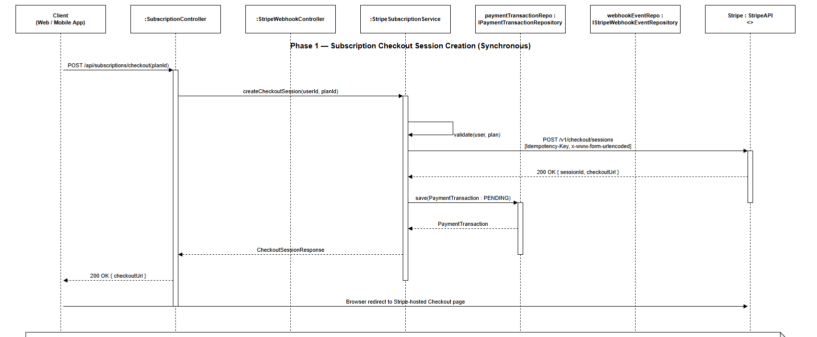
Figure X:
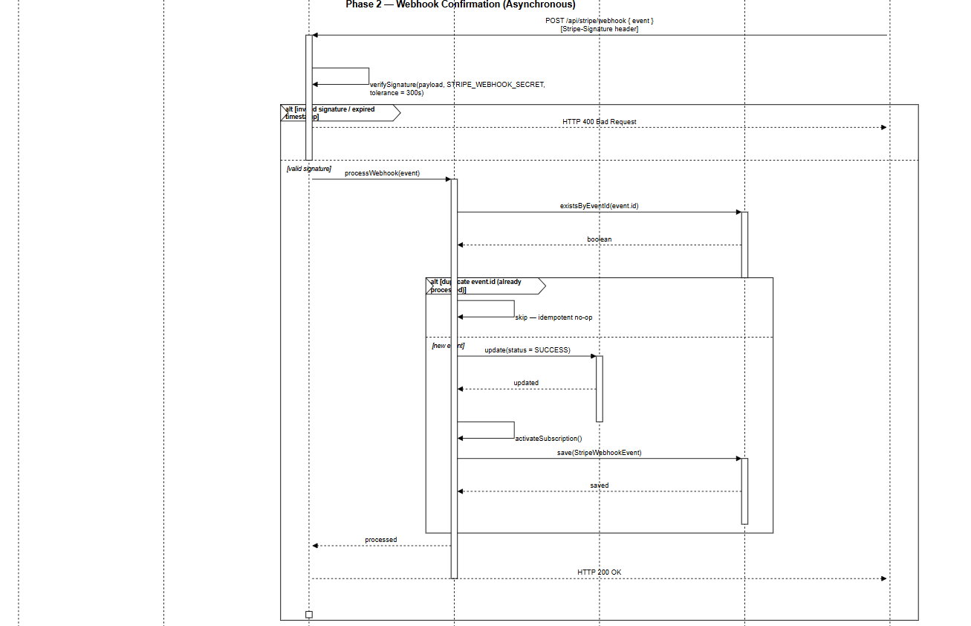
Figure X:

4.4 Asynchronous Communication Design
Aspect | Decision
Message Broker | None — no RabbitMQ, Kafka, or AWS SQS
Internal Async Mechanism | Spring @Async + Spring Application Events
Real-Time Messaging | Spring STOMP/WebSocket Simple Broker
Internal Event Format | Java objects
WebSocket Payload Format | JSON / STOMP
Delivery Guarantee | At-most-once for process-local asynchronous tasks
Durability | Async executor queue is not durable across application restart
Ordering Guarantee | No global ordering guarantee
Consumer ACK | Not applicable for Spring in-memory executors/events
Dead Letter Queue | None
Automatic Retry | None for normal @Async tasks

Internal Asynchronous Jobs / Events

Event / Queue Name | Producer | Consumer(s) | Trigger | Payload Summary
authorUploadExecutor task | AuthorChapterController | AuthorUploadAsyncService | Author uploads chapter folder | taskId, comicId, chapter request, images, relative paths
NotificationPushEvent | NotificationService / BroadcastService | NotificationPushEventListener → PushNotificationSender | In-app notification is created | userId, notification data
Comic Vector Scheduled Job | RecommendationScheduler | RecommendationService → Gemini | Comic has no embedding vector | comicId + comic metadata
User Vector Scheduled Job | RecommendationScheduler | RecommendationService | User preference vector requires recalculation | userId
View / Interaction Sync Jobs | Scheduler components | Persistence / Analytics components | Periodic cache synchronization | Cached interaction/view data

4.5 Architecture-Specific Communication Patterns

Monolith — Transaction Boundary Design

Use Case / Method | Transaction Scope | Operations INSIDE Tx | Operations OUTSIDE Tx (why)
SubmissionController.approve() | @Transactional | Update submission; publish Comic/Chapter; update comic metadata; create audit/notification data | FCM push occurs after commit; WebSocket notification should also preferably execute through an after-commit listener
AuthorChapterService.uploadChapterFolder() | @Transactional | Validate chapter; upload pages; create Chapter; update comic metadata | Cloudinary network calls currently occur during transaction; recommended to upload first and persist results in a shorter DB transaction
AuthorComicService.submitForReview() | @Transactional | Validate ownership/state; create/update submission state | External notification delivery should remain outside transaction
StripeSubscriptionService.createCheckoutSession() | @Transactional | Validate user/plan; call Stripe Checkout; create pending PaymentTransaction | Stripe call should ideally be separated from the shortest possible DB transaction
StripeSubscriptionService.processWebhook() | @Transactional | Deduplicate Stripe event; update payment; update subscription; persist webhook event | HTTP success is returned after processing; failure allows Stripe redelivery
CreatorPayoutService.createRequest() | @Transactional | Validate amount; calculate available revenue; reserve payout request; save PENDING | No external transfer is performed during payout request creation
CreatorPayoutService.payWithStripe() | @Transactional(noRollbackFor = CustomException.class) | Lock request; mark PROCESSING; call Stripe transfer; update PAID or FAILED | Recommended flow: Tx1 PROCESSING → commit → Stripe call → Tx2 PAID/FAILED
NotificationService.notifyUser() | @Transactional | Save in-app notification and publish notification event | FCM executes after commit through @TransactionalEventListener + @Async; WebSocket should preferably also execute after commit

Part 5 — Security Design

5.1 Authentication Flow
The complete authentication sequence, JWT structure, token expiration, Google OAuth2 flow, email verification, and password-recovery process are documented in Part 2.2 — Authentication & Session / Token Design.

ComiVerse uses stateless JWT authentication. Protected requests send the access token through:

Authorization: Bearer {accessToken}

5.2 Authorization & RBAC Implementation
Aspect | Decision
RBAC implementation | Spring Security validates JWTs through TokenAuthenticationFilter. Endpoint permissions are enforced using SecurityFilterChain, @PreAuthorize, and service-layer authorization checks.
Global roles | READER, TRANSLATOR, AUTHOR, MODERATOR, and ADMIN. Guest access represents an unauthenticated request and is not stored as a role.
Role storage | Global roles are stored in PostgreSQL with the user account and included in the JWT role claim.
Translation-team roles | GROUP_OWNER, GROUP_MANAGER, PROOFREADER, and QUALITY_CHECKER are stored separately in translation-group membership records. They are not included in the global JWT.
Role hierarchy | No automatic Spring Security role hierarchy is currently assumed. Each endpoint explicitly declares its allowed roles. Some moderation endpoints permit both MODERATOR and ADMIN.
Permission check layer | URL and role permissions are checked by Spring Security and controller annotations. The service layer checks resource ownership, translation-team membership, assigned tasks, premium access, and valid workflow state.
Account status check | The authentication filter reloads the current user. Deleted, suspended, blocked, inactive, or unverified accounts are rejected even if the submitted JWT has not expired.
Author ownership check | Author services compare the authenticated user UUID with the owner of the requested comic or chapter.
Translation permission check | Translation services verify team membership, team-level role, project membership, and task assignment using current database records.
Premium access check | The chapter service verifies publication state and premium entitlement before returning protected chapter content.
Failed authentication response | HTTP 401 Unauthorized with AUTH_001 for missing, malformed, invalid, or expired authentication.
Failed authorization response | HTTP 403 Forbidden with AUTH_002 when the authenticated user lacks the required role, ownership, or membership. Required roles and internal permission rules are not disclosed.

5.3 Data Protection
Data Category | At Rest | In Transit | Notes
All production traffic | N/A | TLS 1.2 or higher | HTTP requests are redirected to HTTPS by the production reverse proxy or hosting platform. HSTS is enabled only after HTTPS is correctly configured.
Passwords | BCrypt password hash | TLS | Configure BCryptPasswordEncoder(12) to meet NFR-SEC-02. Plain-text passwords are never stored, returned, or logged.
Email verification OTP | SHA-256 digest with expiration | TLS | The plain OTP is sent through Resend but is not stored. OTPs expire after five minutes and are invalidated after successful use.
Password-reset OTP | SHA-256 digest with expiration | TLS | Reset OTPs are single-use and are cleared after password reset.
PII: name, email, profile information | Stored in PostgreSQL with restricted database access; no application-level field encryption is currently implemented | TLS | PII is excluded from logs where possible. Account deletion or anonymization follows NFR-C02. Lack of field-level encryption is an accepted current risk that must be reviewed before production.
Payment-card data | Not stored by ComiVerse | TLS | Current plan upgrade is a demo operation. When a payment gateway is integrated, ComiVerse stores only gateway transaction references, amount, status, and timestamps.
Access and refresh tokens | Currently stored in browser localStorage | TLS | This reflects the current implementation but exposes tokens if XSS succeeds. Tokens must never appear in logs.
Production refresh token target | Secure, HttpOnly, SameSite=Lax cookie | TLS | Requires a refresh endpoint, token rotation, revocation support, and CSRF protection.
OAuth2 tokens | Currently transferred to the React callback through query parameters | TLS | This is a current implementation risk. Production should use a one-time authorization code or HttpOnly cookie because URLs may appear in history and logs.
API keys and external credentials | Backend environment variables or deployment secret manager | TLS | Secrets are never committed to Git, returned through APIs, or printed in logs.
Frontend environment variables | Included in the compiled React bundle | TLS | Only public configuration may use the VITE_ prefix. Resend, Gemini, Cloudinary secret, JWT secret, and database credentials must never use VITE_.
Comic and chapter assets | Stored through Cloudinary | TLS | Premium and unpublished assets should use signed or restricted delivery URLs rather than permanent unrestricted public URLs.
Redis data | Restricted Redis instance with expiration where applicable | TLS in production deployment | Redis contains temporary counters, progress, and cached data. It must not be publicly accessible.
Audit logs | Stored in PostgreSQL with restricted access | TLS | Audit records must not contain passwords, OTPs, JWTs, API keys, complete payment information, or sensitive request body.

5.4 Input Validation Strategy
Validation Type | Where Applied | Library / Mechanism | Example
Client-side validation | React forms | HTML constraints and form validation | Check required fields, email format, length, and numeric range before submission.
Bean validation | Controller request DTOs | Jakarta Bean Validation using @Valid, @NotNull, @NotBlank, @Email, @Size, @Min, and @Max | @NotBlank @Size(max = 100) String title
Business-rule validation | Service layer | Custom validators and typed application exceptions | Only the comic owner may update or submit the comic.
Role validation | Security and service layers | @PreAuthorize and current authenticated principal | Only MODERATOR or ADMIN may approve content.
Ownership validation | Service layer | Compare authenticated user UUID with resource owner UUID | Author UUID must match the comic’s owner UUID.
Team membership validation | Translation service layer | Membership and team-role repository lookup | A translator must belong to the relevant project before accessing its workspace.
Workflow validation | Service layer | Explicit state-transition checks | A rejected or published submission cannot be approved as though it were pending.
SQL injection prevention | Repository layer | Spring Data JPA parameterized queries and prepared statements | User input is never concatenated into SQL, JPQL, or native queries.
XSS prevention | React presentation layer and backend | React automatic text escaping, HTML sanitization, and Content Security Policy | Forum content is rendered as text unless permitted rich text has been sanitized.
Path parameter validation | Controller and service layers | UUID parsing and entity existence checks | Reject malformed comicId, chapterId, taskId, or userId values.
Pagination validation | Controller layer | @Min, @Max, and default values | page >= 0 and 1 <= size <= 100.
Enum validation | DTO and service layers | Java enum binding and explicit allowed-value checks | Reject unknown comic, task, transaction, or moderation statuses.
File upload validation | Controller and service layers | MIME whitelist, extension verification, magic-byte checks, maximum size, generated filenames, and Cloudinary validation | Accept only approved JPEG, PNG, WebP, ZIP, and CBZ files.
Archive validation | Upload service | ZIP-entry path validation and extraction limits | Reject ../ paths, executable files, excessive entry counts, and decompression bombs.
Rate limiting | Authentication and public endpoints | Account/IP-based counters | Applied to login, registration, OTP resend, OTP verification, password reset, comments, and chat.
Request-size validation | Web server and controller | Spring multipart and request-size configuration | Reject request bodies or archives that exceed configured limits.

5.5 Security Headers & CORS Policy
Header | Value | Reason
Strict-Transport-Security | max-age=31536000; includeSubDomains | Forces future browser requests to use HTTPS. Enabled only in production over HTTPS.
X-Content-Type-Options | nosniff | Prevents MIME-type sniffing.
X-Frame-Options | DENY | Prevents the application from being embedded in a frame and reduces clickjacking risk.
Content-Security-Policy | Defined below | Restricts scripts, styles, images, network connections, and embedding sources.
Referrer-Policy | strict-origin-when-cross-origin | Restricts referrer information sent to external websites.
Permissions-Policy | camera=(), microphone=(), geolocation=() | Disables browser capabilities that ComiVerse does not currently require.
Cache-Control | no-store for authentication and sensitive responses | Prevents sensitive data from being stored in shared or browser caches.

Environment | Allowed Origins | Allowed Methods | Allow Credentials
Development | http://localhost:5173 | GET, POST, PUT, PATCH, DELETE, OPTIONS | FALSE
Staging | https://staging.[domain] | GET, POST, PUT, PATCH, DELETE, OPTIONS | FALSE
Production | https://[domain] | GET, POST, PUT, PATCH, DELETE, OPTIONS | FALSE

Part 6 — Key Algorithms & Business Logic
ComiVerse implements business state transitions using explicit status enums and service/controller guard conditions. Complex workflows such as comic moderation, chapter moderation, translation review, creator payout, and payment processing are executed inside Spring transactional service methods.
The system does not currently use the Spring State machine. State transitions are intentionally kept explicit because each workflow contains a limited number of states and business-specific guard conditions.

6.1 State Machine Implementation

6.1.1 State Machine Design Decision
Aspect | Decision
Pattern | Plain conditionals + Enum-based states + explicit guard validation
Reason | Current workflows have a moderate number of states and business-specific guards. Explicit transition logic is easier to trace and maintain than introducing Spring Statemachine
State Storage | PostgreSQL entity status fields
Guard Implementation | Service/controller validation before changing entity state
Authorization Guard | Spring Security @PreAuthorize plus ownership/team-leader validation
Transaction Handling | State change and dependent database updates execute inside the same @Transactional boundary
Invalid Transition Response | HTTP 409 Conflict
Invalid Request / Event | HTTP 400 Bad Request
Unauthorized Actor | HTTP 403 Forbidden
Missing Entity | HTTP 404 Not Found
External Provider Failure | HTTP 502 Bad Gateway where applicable
Audit Handling | Moderation and administrative transitions generate audit records where implemented
External Notification | Executed after commit where possible so notification failure does not rollback business state
State-machine Framework | None

6.1.2 Generic State Transition Algorithm

State Machine Pseudocode
function transitionStatus(entity, event, actor, context):

currentState = entity.status

transition =
TRANSITION_MAP[entity.type]
[currentState]
[event]

// 1. Validate state transition
if transition does not exist:
throw InvalidStateTransitionException(
entity.type,
currentState,
event
)
// HTTP 409

// 2. Validate actor authorization
if actor.role not in transition.allowedRoles:
throw ForbiddenException()
// HTTP 403

// 3. Evaluate business guard conditions
for guard in transition.guards:

if not guard.evaluate(entity, actor, context):

throw GuardConditionNotMetException(
guard.reason
)

previousState = entity.status

// 4. Apply target state
entity.status = transition.targetState

// 5. Execute operations that must remain atomic
for action in transition.transactionalActions:

action.execute(
entity,
actor,
context
)

// 6. Persist final state
save(entity)

// 7. Record important state transition
if transition.requiresAudit:

createAuditLog(
entity.id,
previousState,
entity.status,
event,
actor.id,
now()
)

// 8. Register external communication
// only after successful transaction commit
registerAfterCommitActions(
transition.afterCommitActions
)

return entity

Conceptual transition definition:
TRANSITION_MAP = {

ENTITY_TYPE: {

CURRENT_STATE: {

EVENT: {

targetState: NEXT_STATE,

allowedRoles: [
ROLE_A,
ROLE_B
],

guards: [
guardCondition1,
guardCondition2
],

transactionalActions: [
databaseAction1,
databaseAction2
],

afterCommitActions: [
notificationAction
]
}
}
}
}

6.1.3 Comic / Chapter Publication State Machine

A. Comic Moderation State Transition Table

Current State | Event | Actor | Guard Condition | Next State | Main Side Effects
DRAFT | Submit for Review | Author | Author owns comic; comic has ≥ 1 chapter; no pending comic-profile submission | SUBMITTED_FOR_REVIEW | Create moderation submission
REJECTED | Edit moderation-sensitive content | Author | Author owns comic | DRAFT | Clear obsolete moderation state; prepare for resubmission
PUBLISHED | Edit moderation-sensitive content | Author | Author owns comic | DRAFT | Updated profile requires moderation again
SUBMITTED_FOR_REVIEW | Approve | Moderator / Admin | Submission is still PENDING | PUBLISHED | Approve submission; publish comic; publish eligible initial chapters; refresh metadata
SUBMITTED_FOR_REVIEW | Reject | Moderator / Admin | Submission is still PENDING; rejection reason supplied | REJECTED | Reject submission; save reason; notify Author
REJECTED / disputed moderation state | Submit Appeal | Author | Appeal reason is supplied | UNPUBLISHED | Store appeal information; notify Moderator/Admin
SUBMITTED_FOR_REVIEW | Comic becomes empty | System | No non-deleted chapter remains | DRAFT | Cancel pending comic-profile submission

Comic State Diagram
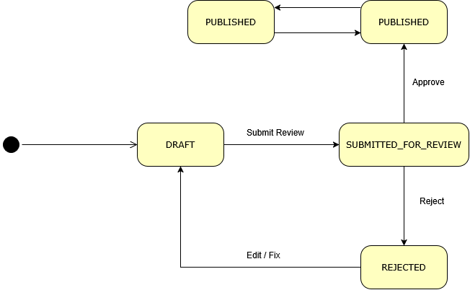

B. Chapter Moderation State Transition Table

Current State | Event | Actor | Guard Condition | Next State | Main Side Effects
DRAFT | Upload valid chapter assets | Author | Folder contains valid chapter images | PREVIEW_READY | Save chapter/page asset information
PREVIEW_READY | Submit for Review | Author | Chapter has images; no identical previously rejected content hash | SUBMITTED_FOR_REVIEW | Create chapter moderation submission
REJECTED | Replace / modify chapter assets | Author | New assets differ from rejected content | PREVIEW_READY | Recalculate content hash; prepare resubmission
PUBLISHED | Replace moderated chapter assets | Author | Author owns comic/chapter | PREVIEW_READY | New version requires review
SUBMITTED_FOR_REVIEW | Approve | Moderator / Admin | Submission still pending | PUBLISHED | Publish chapter; update comic metadata; notify translation teams
SUBMITTED_FOR_REVIEW | Reject | Moderator / Admin | Submission still pending; reason supplied | REJECTED | Store rejection reason
PREVIEW_READY | Delete all valid assets | Author | No valid images remain | DRAFT | Chapter is no longer review-ready

Chapter State Diagram

6.1.4 Translation Task State Machine
Current State | Event | Actor | Guard Condition | Next State | Main Side Effects
in_progress | Submit for Review | Translator / authorized team actor | Task has pages; every page is DONE; every completed page has responsible Translator | under_review | Save review baseline for each page; notify Project Leader
under_review | Request Changes | Project Leader | Actor is leader of task's team | in_progress | Clear completion time; Translator continues editing
under_review | Approve | Project Leader | Actor is team leader; all pages remain ready | completed | Publish translated chapter; set completion time; create Translator settlement
completed | Revoke Published Translation | Moderator / Admin | Reason is supplied | in_progress | Remove published translation; reverse latest settlement; decrement team completion count
completed | Manual direct status edit | Project Leader | Not allowed | No Change | Reject; completion must go through review flow

Translation Task Pseudocode
function submitTranslationForReview(taskId, actor):

task = loadTask(taskId)

require actor is:
assigned Translator
OR authorized Project Leader

require task.status == "in_progress"

pages = loadTaskPages(taskId)

if pages is empty:
reject 409

for page in pages:

if page.status != DONE:
reject 409

if page.assignedTranslatorId == null:
reject 409

task.status = "under_review"
task.completedAt = null

for page in pages:
page.reviewBaseline =
page.currentTranslation

save(task)
saveAll(pages)

afterCommit:
notifyProjectLeader()

Translation Task State Diagram
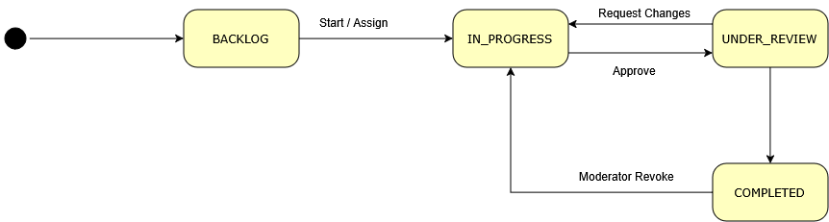

6.1.5 Creator Payout State Machine

Current State | Event | Actor | Guard Condition | Next State | Main Side Effects
— | Request Payout | Author / Translator | Closed payout month; available balance sufficient; payout profile/config valid | PENDING | Reserve payout amount
PENDING | Approve | Admin | Stripe payout account is READY; currency still matches | APPROVED | Store Stripe account information; approval timestamp
PENDING | Reject | Admin | Request exists | REJECTED | Store rejection note
APPROVED | Reject | Admin | Payment has not started | REJECTED | Store rejection note
APPROVED | Pay | Admin | Stripe account READY; amount > 0; currency matches | PROCESSING | Begin Stripe transfer
FAILED | Retry Pay | Admin | Stripe account still valid | PROCESSING | Retry Stripe transfer
PROCESSING | Stripe Transfer Success | System | Stripe returns transfer ID | PAID | Save transfer ID and paid time
PROCESSING | Stripe Transfer Failure | System | Stripe/API failure | FAILED | Save failure reason and failure time
PAID | Pay Again | Admin | Existing Stripe transfer ID exists | PAID | Return existing result; no second transfer

Creator Payout Pseudocode

function processPayout(payoutId):

payout = loadPayoutForUpdate(payoutId)

if payout.status == PAID
and payout.stripeTransferId exists:

return payout

if payout.status not in
[APPROVED, FAILED]:

reject 409

account =
requireReadyStripePayoutAccount(
payout.userId
)

require payout.currency ==
account.currency

require payout.amount > 0

payout.status = PROCESSING
saveAndFlush(payout)

try:

transfer =
Stripe.createTransfer(
payout.account,
payout.amount,
payout.currency,
idempotencyKey = payout.id
)

require transfer.id exists

payout.status = PAID
payout.stripeTransferId =
transfer.id
payout.paidAt = now()

catch providerError:

payout.status = FAILED
payout.failureReason =
providerError.message
payout.failedAt = now()

throw BadGatewayException

save(payout)

return payout

Payout State Overview
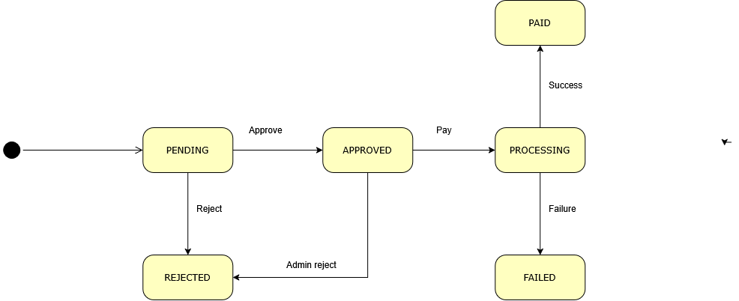

6.1.6 Payment Transaction State Machine

Current State | Event | Source | Guard Condition | Next State | Main Side Effects
— | Create Stripe Checkout | Reader | Valid active plan | PENDING | Create local PaymentTransaction and Stripe Checkout Session
PENDING | Checkout payment confirmed | Stripe Webhook / reconciliation | Payment status is paid or no_payment_required | PAID | Save payment IDs; activate/synchronize subscription
PENDING | Async payment succeeded | Stripe Webhook | Signed valid event | PAID | Synchronize subscription
PENDING | Async payment failed | Stripe Webhook | Signed valid event | FAILED | Save failure reason
PENDING | Invoice payment failed | Stripe Webhook | Matching transaction/subscription | FAILED | Save invoice failure reason
PENDING | Checkout expired | Stripe Webhook | Transaction still PENDING | EXPIRED | Save expiration reason
PAID | Duplicate success event | Stripe | Event already processed or transaction already paid | PAID | No duplicate payment/subscription operation
Any | Duplicate Webhook Event | Stripe | event_id already exists | No Change | Ignore duplicated processing

Payment State Pseudocode

function processStripeEvent(event):

verifyStripeSignature(event)

if webhookEventExists(event.id):
return SUCCESS

transaction =
resolvePaymentTransaction(event)

switch event.type:

case CHECKOUT_COMPLETED:

if event.paymentStatus in
["paid", "no_payment_required"]:

transaction.status = PAID

synchronizeSubscription()

else:

// asynchronous payment method
// remains pending

transaction.status = PENDING

case ASYNC_PAYMENT_SUCCEEDED:

transaction.status = PAID

synchronizeSubscription()

case ASYNC_PAYMENT_FAILED:

transaction.status = FAILED

saveFailureReason()

case INVOICE_PAID:

transaction.status = PAID

synchronizeSubscription()

case INVOICE_PAYMENT_FAILED:

transaction.status = FAILED

saveFailureReason()

case CHECKOUT_EXPIRED:

if transaction.status == PENDING:

transaction.status = EXPIRED

save(transaction)

saveProcessedWebhookEvent(event.id)

return SUCCESS

Payment State Diagram
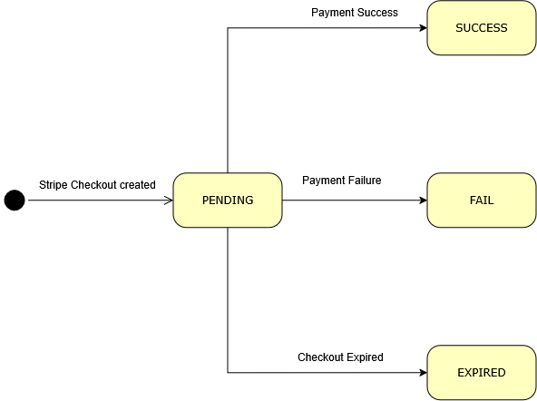

6.2 Concurrency & Consistency Handling
Operation | Race Condition Risk | Strategy | Implementation
Claim Translation Project | Two Project Leaders claim the same UNCLAIMED project at nearly the same time | Pessimistic database locking | Load ProjectTeam using SELECT ... FOR UPDATE / PESSIMISTIC_WRITE; verify status is still UNCLAIMED before changing it to ACTIVE and assigning the leader; otherwise return HTTP 409 Conflict
Create Translation Task | Project Leader submits duplicate requests and creates more than one task for the same chapter in the same team | Service validation + database unique constraint | Check whether a task already exists for (project_team_id, chapter_id) before creation and enforce a DB uniqueness constraint for the same business key
Submit / Review Translation Task | Translator submission and Project Leader review requests happen concurrently or review action is sent twice | Transactional state validation + row locking | Load task in transaction, validate its current state (in_progress or under_review) before changing status; lock the task for approval when settlement/publication side effects are created
Translation Settlement | The same completed task is approved more than once and Translator income is credited twice | Idempotency + database uniqueness | Before creating settlement, search for an existing ACTIVE settlement for the task; enforce a unique settlement key such as (task_id, version_no) and return the existing settlement when already processed
Revoke Published Translation | Revoke and approval operations execute at the same time, causing inconsistent settlement and task state | Pessimistic locking + single transaction | Lock the task/latest settlement; change task back to in_progress, reverse settlement, create negative earning adjustments, and update publication state within one transaction
Creator Payout Request | Multiple payout requests reserve the same available Creator/Translator balance | Transactional balance validation + locking | Calculate available payout balance inside transaction and prevent overlapping active requests for the same creator/month or earning scope
Approve / Reject Creator Payout | Two Admins approve/reject the same request simultaneously | Pessimistic lock + optimistic version | Load payout row using PESSIMISTIC_WRITE; entity version (@Version) detects conflicting updates; validate current state before transition
Execute Stripe Payout | Two requests attempt to create two Stripe transfers for the same payout | Database lock + provider idempotency | Lock payout before changing to PROCESSING; reuse payout ID as stable Stripe idempotency reference; if status is already PAID, return existing transfer instead of creating another
Stripe Webhook Processing | Stripe delivers the same webhook more than once | Event idempotency + DB unique constraint | Store Stripe event_id in stripe_webhook_events; if the event already exists, return success without repeating payment/subscription processing
Subscription Checkout Reconciliation | Webhook and frontend checkout-status reconciliation update the same payment transaction simultaneously | Idempotent state transition | Only allow valid forward transitions such as PENDING → PAID/FAILED/EXPIRED; repeated PAID confirmation does not duplicate subscription activation
Like Comic | Same Reader sends repeated/concurrent like requests | Database uniqueness + idempotent service behavior | Enforce one like record per (user_id, comic_id); repeated like does not create duplicate records
Save / Bookmark Comic | Same Reader submits multiple save requests concurrently | Database uniqueness | Enforce one save/bookmark record per (user_id, comic_id)
Rate Comic | Same Reader submits concurrent rating updates | Unique business key + update existing record | Enforce one rating per (user_id, comic_id); subsequent rating changes update the existing row instead of inserting another
Comic / Chapter View Counter | Many Readers increment the same counter concurrently | Redis atomic operations | Increment view counters atomically in Redis instead of directly updating the same PostgreSQL row on every request; scheduled synchronization persists accumulated deltas
Like / Save Aggregate Counters | Concurrent interaction requests produce lost updates to aggregate values | Redis atomic increment/decrement | Keep interaction deltas in Redis and periodically synchronize them with PostgreSQL
Author Chapter Upload | Async upload worker updates progress while frontend continuously polls status | Thread-safe in-memory task state | Store task status in ConcurrentHashMap; synchronize updates to the individual upload task state
Stripe Webhook Event vs Application Request | Webhook and user/admin API may update related payment information at the same time | Transactional state checks + idempotency | Both flows validate current persisted state; duplicate terminal transitions are ignored or return the existing result
Financial Revenue Data | Redis/cache data becomes inconsistent or is lost before database synchronization | PostgreSQL as financial source of truth | Translator settlements, page earnings, payout balances, and payment transactions must be calculated from durable PostgreSQL records; Redis must not be used as the authoritative source for financial calculations

6.3 Transaction Boundary Design
Generic Transaction Boundary Pseudocode

function executeBusinessUseCase(request, actor):

// -----------------------------------------
// PRE-TRANSACTION VALIDATION
// -----------------------------------------

validateInput(request)
validateAuthentication(actor)
validateAuthorization(actor)

// -----------------------------------------
// DATABASE TRANSACTION
// -----------------------------------------

begin transaction

try:

entity = loadRequiredEntity()

validateOwnership(entity, actor)

validateCurrentState(entity)

validateBusinessRules(entity, request)

// All changes that must succeed or fail together
updatePrimaryEntity()

updateRelatedEntities()

updateBusinessCountersOrMetadata()

createFinancialRecordsIfRequired()

createAuditRecordIfRequired()

createNotificationRecordIfRequired()

commit transaction

catch error:

rollback transaction

throw error

// -----------------------------------------
// AFTER COMMIT
// -----------------------------------------

dispatchWebSocketNotification()

dispatchPushNotification()

dispatchEmailIfRequired()

triggerBackgroundProcessingIfRequired()

return result

Business Area / Use Case | Operations INSIDE Transaction | Operations OUTSIDE Transaction / After Commit | Rollback Requirement | Business Area / Use Case | Operations INSIDE Transaction
Authentication & Account Management | Create/update User; role/profile state; OTP/reset records where persisted | OAuth provider communication, email verification/reset delivery | User/account changes rollback if persistence fails; email failure should not corrupt persisted account state | Authentication & Account Management | Create/update User; role/profile state; OTP/reset records where persisted
Comic Management | Create/update/delete Comic; maintain metadata and ownership information | Cloudinary upload should preferably occur before short persistence transaction | Comic database changes must rollback together | Comic Management | Create/update/delete Comic; maintain metadata and ownership information
Chapter Upload | Save Chapter; page/image URLs; chapter number; update comic chapter metadata | Validate/process folder and upload files to Cloudinary before final short DB transaction; async upload processing remains outside caller transaction | No partially persisted chapter should remain when DB persistence fails | Chapter Upload | Save Chapter; page/image URLs; chapter number; update comic chapter metadata
Submit Comic/Chapter for Moderation | Validate current state; create/update Submission; change Comic/Chapter moderation state; create audit/notification records | WebSocket, FCM and non-critical notification transport | Submission and content state must rollback together | Submit Comic/Chapter for Moderation | Validate current state; create/update Submission; change Comic/Chapter moderation state; create audit/notification records
Approve / Reject Publication | Lock/read submission; update Submission; update Comic/Chapter status; publication metadata; chapter counts; moderation information; audit record | FCM, WebSocket and external notification delivery | Submission and published content must never disagree after commit | Approve / Reject Publication | Lock/read submission; update Submission; update Comic/Chapter status; publication metadata; chapter counts; moderation information; audit record
Translation Team Management | Create/update team; assign/change leader; add/remove members; update team state | Real-time workspace notification | Team and membership changes rollback together | Translation Team Management | Create/update team; assign/change leader; add/remove members; update team state
Claim Translation Project | Lock project row; verify UNCLAIMED; assign Project Leader; change project to ACTIVE; create/update team membership | Notification to newly assigned leader/team | Claim must be atomic so only one Project Leader succeeds | Claim Translation Project | Lock project row; verify UNCLAIMED; assign Project Leader; change project to ACTIVE; create/update team membership
Create / Assign Translation Task | Validate chapter/team; prevent duplicate task; create task; assign Translator; initialize page translation state | WebSocket/push task assignment notification | Task, assignee and related page state must rollback together | Create / Assign Translation Task | Validate chapter/team; prevent duplicate task; create task; assign Translator; initialize page translation state
Translate / Save Page Work | Save translated text, page status, assigned Translator and responsibility information | Optional real-time progress notification | Page editing changes should rollback on persistence error | Translate / Save Page Work | Save translated text, page status, assigned Translator and responsibility information
Submit Translation for Review | Validate all pages; change task to under_review; save review baselines | Notify Project Leader | Task state and page review snapshot must remain consistent | Submit Translation for Review | Validate all pages; change task to under_review; save review baselines
Approve Translation | Validate/lock task; change task to completed; publish translated chapter; create settlement; create page earnings; update completion metadata | Notify Translators/Readers after commit | Publication and Translator revenue records must commit or rollback together | Approve Translation | Validate/lock task; change task to completed; publish translated chapter; create settlement; create page earnings; update completion metadata
Request Translation Changes | Change task from under_review to in_progress; clear completion state | Notify assigned Translator | Task state update must be atomic | Request Translation Changes | Change task from under_review to in_progress; clear completion state
Revoke Published Translation | Lock task/settlement; unpublish translation; revert task state; reverse settlement; create negative earning adjustments; update completion counters | Notify Project Leader and affected Translators | Revocation and financial reversal must rollback together | Revoke Published Translation | Lock task/settlement; unpublish translation; revert task state; reverse settlement; create negative earning adjustments; update completion counters
Reader Interaction — Like / Save / Rating | Create/update/remove authoritative interaction record where PostgreSQL is used | Redis aggregate/cached counter updates may be handled separately | Individual interaction record remains source of truth | Reader Interaction — Like / Save / Rating | Create/update/remove authoritative interaction record where PostgreSQL is used
Views / High-Frequency Analytics | Scheduled PostgreSQL aggregate update | Immediate Redis atomic increment occurs outside normal DB transaction | Eventual consistency is acceptable because data is non-financial analytics | Views / High-Frequency Analytics | Scheduled PostgreSQL aggregate update
Notification Creation | Create persistent NotificationEntity; save preference-related data; publish transactional event | WebSocket and FCM actual delivery after commit | Delivery failure must not rollback completed business use case | Notification Creation | Create persistent NotificationEntity; save preference-related data; publish transactional event
Subscription Checkout Creation | Validate Reader/Plan and persist local payment transaction state | Stripe Checkout Session creation should preferably be separated from long DB transaction | Local payment record must not become falsely PAID when Stripe call fails | Subscription Checkout Creation | Validate Reader/Plan and persist local payment transaction state
Stripe Webhook Processing | After signature verification: deduplicate event; update PaymentTransaction; update ReaderSubscription; persist Stripe webhook event | Push/WebSocket/email notification after commit | Payment, subscription and event-id record must be atomic | Stripe Webhook Processing | After signature verification: deduplicate event; update PaymentTransaction; update ReaderSubscription; persist Stripe webhook event
Creator Payout Request | Calculate available durable earnings; validate eligible month; create PENDING payout reservation | Notification | Same earnings must not be reserved by multiple active payout requests | Creator Payout Request | Calculate available durable earnings; validate eligible month; create PENDING payout reservation
Approve / Reject Payout | Lock payout; validate transition; update status and administrative notes | Notification | Status transition must be atomic | Approve / Reject Payout | Lock payout; validate transition; update status and administrative notes
Execute Stripe Creator Payout | Tx1: lock request and change to PROCESSING; Tx2 after Stripe response: change to PAID or FAILED | Actual Stripe Transfer API call occurs between the two short transactions | External network latency must not keep a long DB transaction/lock open | Execute Stripe Creator Payout | Tx1: lock request and change to PROCESSING; Tx2 after Stripe response: change to PAID or FAILED
Recommendation Embedding | Persist generated vector after successful Gemini response | Gemini embedding request occurs outside DB transaction | Gemini failure must not invalidate existing comic/user data | Recommendation Embedding | Persist generated vector after successful Gemini response
OCR Processing | Save accepted OCR/translation result only after processing succeeds | Gemini OCR request and image retrieval outside DB transaction | External OCR failure should not leave incomplete persisted translation result | OCR Processing | Save accepted OCR/translation result only after processing succeeds
Scheduled Redis Synchronization | Read delta snapshot and apply PostgreSQL aggregate update | Redis atomic collection/reset/subtraction handled independently | Eventual consistency acceptable; financial data must not depend on Redis | Scheduled Redis Synchronization | Read delta snapshot and apply PostgreSQL aggregate update
Audit Logging | Audit record should be committed with the state-changing operation when the audit record proves that operation occurred | External audit export/report generation outside transaction | A state change that requires audit should not commit without its audit record | Audit Logging | Audit record should be committed with the state-changing operation when the audit record proves that operation occurred

6.4 Scheduled Jobs & Background Tasks
Job Name | Schedule (cron) | Description | Idempotency | Failure Handling
View Counter Synchronization | Periodically | Synchronizes accumulated comic and chapter view counters from cache to the database | Delta-based processing; repeated execution does not intentionally duplicate completed increments | Log failure and process remaining data in the next cycle
User Interaction Synchronization | Periodically | Synchronizes cached interaction statistics such as likes, saves, and ratings with persistent data | Uses accumulated changes; safe to continue in later executions | Log failure; retry during the next scheduled execution
Leaderboard Refresh | Periodically | Recalculates and refreshes comic ranking/leaderboard information | Existing ranking results are refreshed or replaced | Keep previous ranking data and retry during the next cycle
Reading History Cleanup | Daily | Removes or cleans obsolete reading-history records according to retention rules | Re-running cleanup does not affect already removed records | Log failure and retry during the next scheduled execution
Comic Recommendation Vector Generation | Periodically | Generates recommendation embeddings for comics that do not yet have valid vectors | Only records requiring generation are selected | Failed records remain eligible for processing in a later cycle
User Preference Vector Refresh | Periodically | Updates recommendation preference vectors when user interaction data changes | Only users requiring recalculation are processed | Log individual failures; retry affected users later
Chapter Upload Processing | Triggered by Author upload | Processes uploaded chapter files/images in the background and stores successfully processed chapter assets | Each upload operation is associated with its own processing task | Mark upload task as failed and return error information to the client
Push Notification Dispatch | Triggered after notification creation | Sends mobile push notifications without blocking the main business transaction | Persistent in-app notification remains the authoritative notification record | Log delivery failure; business operation remains committed

6.5 Notification Dispatch Design

Notification Dispatch Design

Aspect | Design Decision
Notification Channels | In-App Notification, WebSocket, Firebase Cloud Messaging (FCM), Email
Default Channel | In-App notification
Real-Time Channel | STOMP/WebSocket
Mobile Push Channel | Firebase Cloud Messaging (FCM)
Email Channel | Gmail SMTP or Resend
Channel Routing | Channel is selected according to notification type, user preference, registered device availability, and delivery purpose
Recipient Resolution | Recipient is determined from the related business operation, user ID, role, project/team membership, or moderation responsibility
Template Management | Notification title, message, type, and optional action URL are generated from predefined application-level message formats
User Preferences | Notification is sent only when the corresponding notification preference is enabled, where applicable
In-App Persistence | Notification record is stored in PostgreSQL before external delivery
WebSocket Delivery | Used for real-time notification when the user is connected
Push Delivery | FCM is used when push notification is enabled and the user has an active registered device token
Email Delivery | Primarily used for authentication/account-related messages such as verification and password recovery
Dispatch Timing | External notification delivery should occur after the related business transaction commits
Retry Policy | No general automatic application-level retry; failed asynchronous delivery is logged and may be attempted again by the relevant process where applicable
Delivery Failure | Failure of FCM, WebSocket, or email does not rollback the original business operation
Invalid Device Token | Invalid/unregistered FCM tokens are removed or disabled
Suppression Rules | Do not send when user is inactive/deleted, notification preference is disabled, required recipient information is missing, or the target channel is unavailable
Audit / Logging | Delivery failures and important notification operations are logged

Channel Routing Table

Condition / Notification Purpose | In-App | WebSocket | FCM Push | Email
Normal workflow notification | Yes | Yes | If enabled | No
Moderation / project update | Yes | Yes | If enabled | Optional / No
Translation task update | Yes | Yes | If enabled | No
Payment / payout status update | Yes | Yes | If enabled | Optional
Account verification | No / Optional | No | No | Yes
Password recovery | No | No | No | Yes
User disabled notification preference | No | No | No | No, except mandatory account/security messages
No registered mobile device | Yes | Yes | No | Depends on notification type
User offline | Yes | Delivered when applicable | Push if available | Depends on notification type
FCM/WebSocket delivery failure | Remains stored | Failure logged | Failure logged | Not automatically used as fallback

Notification Suppression Rules

Condition | Action
User account is deleted | Do not dispatch notification
User account is inactive/disabled | Suppress normal workflow notifications
Notification preference is disabled | Skip the corresponding optional notification
Recipient does not belong to the related project/team | Do not send project-specific notification
Moderator is not responsible for the relevant content scope | Do not send moderation notification
No valid FCM device token exists | Skip push notification while retaining in-app notification
External notification provider is unavailable | Log failure; do not rollback the business operation
Duplicate notification event is detected where applicable | Avoid creating/sending unnecessary duplicate notifications

Notification Dispatch Pseudocode
function dispatchNotification(notification):

recipient = resolveRecipient(notification)

if recipient does not exist:
return SUPPRESSED

if recipient is inactive or deleted:
return SUPPRESSED

if notification preference is disabled:
return SUPPRESSED

save in-app notification

after transaction commit:

if real-time delivery is available:
send WebSocket notification

if push notification is enabled
and recipient has valid device token:
send FCM notification

if notification requires email:
send email

if external delivery fails:
log failure

return notification

Part 7 — Performance & Scalability Design

7.1 Caching Strategy
What is Cached | Cache Key Pattern | TTL | Invalidation Trigger | NFR Satisfied
Comic details | comic:detail:{comicId} | 24 hours | Removed when comic information is updated and after view, like, save, or rating aggregates are synchronized | NFR-P03
Chapter detail metadata | chapter:detail:meta:{chapterId} | 3 days | Removed when the chapter is updated or deleted | NFR-P01, NFR-P03
Published chapter list | comic:chapters:list:{comicId} | 3 hours | Removed when a chapter is created, updated, deleted, approved, or rejected | NFR-P01, NFR-P03
Comic and chapter view deltas | Redis hashes comic:view:counter and chapter:view:counter, using IDs as hash fields | No explicit TTL; synchronized every 5 minutes | ViewSyncScheduler writes accumulated deltas to PostgreSQL and evicts affected comic-detail entries | NFR-P03, NFR-S01
Duplicate-view protection | view:lock:{user-or-guest}:chapter:{chapterId} | 10 minutes | Expires automatically | NFR-P03
Like, save, and rating aggregate deltas | comic:like:counter, comic:save:counter, comic:rating:count:counter, comic:rating:sum:counter | No explicit TTL; synchronized every hour | UserInteractionSyncScheduler updates aggregate columns in PostgreSQL and evicts affected comic-detail entries | NFR-P03, NFR-S01
Leaderboards | comic:leaderboard:{day|week|month} | No explicit TTL; overwritten every 15 minutes | LeaderboardScheduler recalculates the top 20 comics. A cache miss also triggers recalculation | NFR-P01, NFR-P03
User snapshot | user:snapshot:{userId} | 1 hour | Expires automatically; no general event-based invalidation is currently implemented | NFR-P03
React comment pages | {targetType}_{targetId}_root_p{page} | In-memory for the current browser session; no fixed TTL | Displayed immediately and then revalidated from the API. Cleared after comment mutations | NFR-P01, NFR-P03
Chapter images and covers | Cloudinary secure_url | Controlled by Cloudinary and the browser/CDN; no application-defined 30-day TTL | Chapter uploads generate UUID-based Cloudinary public IDs. Explicit Cloudinary cache purging is not implemented | NFR-P01, NFR-U01

7.1.1 Caching Notes & Limitations

- Recommendation Vectors: User and comic recommendation vectors are not Redis cache entries. They are persistent derived data stored directly in PostgreSQL (users.user_vector, comics.summary_vector). The RecommendationScheduler generates and recalculates these asynchronously.
- Interaction Counters: Likes and saves are written to PostgreSQL immediately to prevent data loss. Redis temporarily holds only the aggregate counter deltas to speed up the update of comics.like_count and comics.save_count.
- In-Memory Cache: Besides Redis, the system uses a small React in-memory stale-while-revalidate cache for comments, and a Guava in-process cache strictly for 5-minute email OTP storage.
- Current Limitation: Redis counter hashes and leaderboards currently have no explicit TTL/expiry. Production monitoring is required to prevent stale keys if the schedulers fail.

7.2 Database Query Optimization
Query Scenario | Volume Estimate | Optimization Applied | Index Used
Public comic exploration | 15 comics per request in the React Explore page | Cursor/keyset pagination using the selected sort value and comic UUID as the tie-breaker; filters enforce deleted = false and moderation_status = PUBLISHED | idx_comics_moderation_deleted
Public search | 15 comics per request | Database-side filtering by title, genre, author, publication state, and moderation state | idx_comics_moderation_deleted; wildcard text searches currently have no trigram or full-text index
Author-owned comics | Up to 100 comics in the current React Author Comics request | Offset pagination with a fast path when no search text is supplied; the expensive genre/author search query is used only when required | idx_comics_author_deleted
Recommendation feed | Usually 8–10 comics per request | Cursor pagination and native pgvector cosine distance using the <=> operator; popular comics are used when the user has no preference vector | No HNSW or IVFFlat vector index is currently defined
Similar comics | Limited top-N result set | Native PostgreSQL cosine-distance query with LIMIT | No ANN vector index currently defined
Published chapter list for the reader | Full chapter metadata list for one comic, typically 10–100 chapters | Lightweight DTO projection excludes chapter images and avoids loading the full chapter entity; the result is cached in Redis for three hours | idx_chapters_comic_number_deleted and idx_chapters_moderation_deleted
Comic and chapter comments | 10 comments per request | Offset pagination with separate ordering for root comments and replies | Repository-level filtering; dedicated composite comment indexes should be verified before large-scale deployment
Admin and management lists | Usually 10–100 records per request | Spring Data Pageable with server-side filtering and sorting | Entity-specific indexes, such as payment status/date and user identity indexes
7.2.1 Pagination Strategy
- Cursor-based pagination: Used for Explore and Recommendation feeds because these datasets grow continuously and receive frequent updates. It avoids the increasing scan cost and result-shifting of large offsets.
- Offset pagination: Used for bounded administrative, author, and moderation screens where users need direct page navigation and result sets are smaller.
- Unpaginated Data: The reader chapter list currently returns lightweight metadata for all published chapters of a single comic, relying heavily on Redis caching.
7.2.2 Known Database Limitations
- pgvector Indexing: The current pgvector queries perform exact cosine-distance ordering. The summary_vector column does not yet have an HNSW or IVFFlat index. This is a known limitation that must be addressed (verified using EXPLAIN ANALYZE) before scaling recommendations to >100,000 comics.
- Full-text Search: The public search query patterns uses equivalent to LOWER(column) LIKE '%keyword%'. Normal B-tree indexes cannot efficiently support this. PostgreSQL full-text search or pg_trgm GIN indexes are recommended future improvements if catalog search becomes a bottleneck.

7.3 Scaling Approach
NFR Target | Current Approach | Scaling Mechanism | Constraint
NFR-S01: Support at least 5,000 concurrent users | The Spring Boot backend is packaged as a Java 21 Docker container and deployed as a Railway service. Shared PostgreSQL and Redis services are used | The HTTP API can be replicated behind a load balancer after shared-state and scheduler constraints are resolved. The Vite/React static bundle can be deployed and scaled independently through an edge/static hosting platform | No repository evidence currently demonstrates multiple active Railway replicas or a successful 5,000-user load test
NFR-S04: Stateless application services | Spring Security uses SessionCreationPolicy.STATELESS and JWT authentication | Any backend instance can validate the same JWT when configured with the same signing secret. Shared Redis stores view counters, interaction deltas, leaderboards, and reading-history queues | The JWT contains the user ID, but the backend still loads current user details and authorities from PostgreSQL for authenticated requests
NFR-S04: Multi-instance real-time communication | WebSocket/STOMP is available for chat and live notifications | Replace the in-process STOMP simple broker with a shared broker such as RabbitMQ before running multiple application replicas | enableSimpleBroker stores subscriptions inside one application instance and does not broadcast across replicas
NFR-S04: Shared transient security state | Most performance-related transient data is stored in Redis | Move OTP storage and authentication throttling to Redis with TTL-based keys | OTP cache and some throttling state are currently stored in application memory and are not shared between replicas
NFR-S01: Safe scheduled processing | View, interaction, recommendation, and leaderboard schedulers run inside Spring Boot | Add a distributed scheduler lock or move scheduled jobs to a dedicated worker instance | Without coordination, every Railway replica would execute the same scheduled jobs
NFR-S01: High-concurrency request processing | Java 21 and embedded Tomcat are used | Tune Tomcat and HikariCP using measured production workloads; Virtual Threads may be enabled only after compatibility and load testing | Virtual Threads are not currently enabled in application.properties; HikariCP uses default pool settings
NFR-S02: Support at least 1,000,000 chapters | PostgreSQL stores chapter metadata and Cloudinary URLs, while Cloudinary stores and delivers image files | Scale PostgreSQL indexes and connection capacity independently from media storage; keep chapter images outside the relational database | No table partitioning strategy is currently implemented, and the full chapter list for one comic is returned without pagination
NFR-P01 and NFR-U01: Responsive reader media | React renders Cloudinary URLs directly and uses responsive reader layouts | Cloudinary offloads image byte delivery from Railway and supports CDN delivery | Explicit responsive Cloudinary transformations, application-defined CDN TTLs, and cache-purge calls are not currently implemented
NFR-S01: Support at least 5,000 concurrent users | The Spring Boot backend is packaged as a Java 21 Docker container and deployed as a Railway service. Shared PostgreSQL and Redis services are used | The HTTP API can be replicated behind a load balancer after shared-state and scheduler constraints are resolved. The Vite/React static bundle can be deployed and scaled independently through an edge/static hosting platform | No repository evidence currently demonstrates multiple active Railway replicas or a successful 5,000-user load test
NFR-S04: Stateless application services | Spring Security uses SessionCreationPolicy.STATELESS and JWT authentication | Any backend instance can validate the same JWT when configured with the same signing secret. Shared Redis stores view counters, interaction deltas, leaderboards, and reading-history queues | The JWT contains the user ID, but the backend still loads current user details and authorities from PostgreSQL for authenticated requests

7.4 Load Testing Plan
NFR | Test Type | Tool | VUs | Ramp-up | Duration | Pass Threshold
NFR-P01 | Reader API and chapter image delivery | k6 for Spring APIs and Cloudinary requests; Playwright or Lighthouse for browser rendering | 0 → 100 → 500 → 1,000 VUs, with realistic reading delays | 2 minutes | 5 minutes at peak | API p95 < 2.0s, HTTP error rate < 1%, reader content visible within 2.0s under the agreed test environment
NFR-P03 | Explore, search, leaderboard, and recommendation queries | k6 | 0 → 100 → 250 → 500 VUs | 2 minutes | 5 minutes at peak | p95 < 3.0s, error rate < 1%; PostgreSQL slow queries must be reviewed with EXPLAIN ANALYZE
NFR-S01 | Mixed global workload containing reads, comments, likes, saves, authentication, and WebSocket connections | k6 with staged executors; a WebSocket-capable test client for STOMP traffic | 500 → 1,000 → 2,500 → 5,000 active users | 10 minutes | 10 minutes at 5,000 users | Error rate < 2%, no unbounded latency increase, backend CPU < 85%, DB pool usage < 80%, and no Redis or scheduler consistency errors
NFR-S02 | Large chapter dataset and chapter-list access | k6 plus PostgreSQL query analysis | Seed at least 1,000,000 chapters, then execute reader and management queries concurrently | 5 minutes | 10 minutes | Required queries stay within their NFR latency thresholds and do not perform unexpected sequential scans
NFR-S04 | Multi-replica consistency | k6 and WebSocket integration tests against at least two backend replicas | Requests distributed across both replicas | 2 minutes | 10 minutes | JWT authentication, Redis counters, notifications, WebSocket messages, and scheduled synchronization remain consistent across replicas

Part 8 — Error Handling & Observability

8.1 Error Code Registry
Error Code | HTTP Status | User-Facing Message | Internal Trigger | SRS Reference
AUTH_001 | 401 | Session expired or invalid. Please log in again. | Missing, malformed, invalid, unsupported, or expired JWT | FT-01
AUTH_002 | 403 | You do not have permission to perform this action. | Authenticated user does not have the required role or authority | FT-01
AUTH_003 | 401 | Your account is currently unavailable. | User account is locked, banned, disabled, or inactive | FT-01, FT-18
AUTH_004 | 401 | Authentication failed. | Invalid login credentials, OAuth authentication, or external identity token | FT-01
AUTH_429 | 429 | Too many authentication requests. Please try again later. | OTP send/verification or authentication throttle exceeded | FT-01
VAL_001 | 400 | Invalid request data provided. | DTO/Bean Validation failure such as missing or invalid fields | General
VAL_002 | 400 | Invalid request parameter format. | Invalid UUID, enum, number, JSON parameter, or path/query value | General
VAL_003 | 413 | Uploaded content exceeds the allowed limit. | Multipart request too large or too many chapter files/pages | FT-03
RES_001 | 404 | The requested resource was not found. | Generic entity does not exist or is no longer available | General
USER_001 | 404 | User was not found. | User/account/profile ID does not exist | FT-02, FT-18
USER_002 | 409 | The account cannot perform this operation in its current state. | Duplicate role change, ban/unban conflict, or invalid account-state transition | FT-02, FT-18
COMIC_001 | 404 | Comic was not found. | Comic does not exist, was deleted, or is outside the user's permitted scope | FT-03, FT-09
COMIC_002 | 400 | Invalid comic information. | Missing title/language/cover, invalid age, genre, or other comic data | FT-03
COMIC_003 | 409 | The comic cannot perform this operation in its current state. | Comic already submitted, already published, or another invalid moderation-state transition | FT-03, FT-04
CHAPTER_001 | 404 | Chapter was not found. | Chapter does not exist or is unavailable to the requesting user | FT-03
CHAPTER_002 | 400 | Invalid chapter upload data. | Empty folder, malformed path list, unsupported chapter data, or invalid image content | FT-03
CHAPTER_003 | 409 | The chapter cannot perform this operation in its current state. | Duplicate/rejected content, already submitted chapter, or invalid moderation transition | FT-03, FT-04
MOD_001 | 404 | Moderation submission was not found. | Submission, appeal, or moderation record does not exist | FT-04, FT-15
MOD_002 | 409 | This moderation request has already been processed or is no longer valid. | Approve/reject attempted on an already processed or invalid submission state | FT-04
MOD_003 | 400 | Moderation information is incomplete. | Required rejection reason, appeal reason, or moderation decision data is missing | FT-04, FT-15
TEAM_001 | 404 | Translation project or team was not found. | ProjectTeam does not exist or is unavailable | FT-06
TEAM_002 | 403 | You are not authorized to access this translation team. | User is not a team member, Translator, or Project Leader required by the operation | FT-06
TEAM_003 | 409 | The translation project cannot perform this operation in its current state. | Project already claimed, inactive, or incompatible team-state transition | FT-06
TRANS_001 | 404 | Translation task or page was not found. | TeamTask or translation page does not exist | FT-06
TRANS_002 | 409 | The translation task is not ready for this operation. | Pages incomplete, task already completed, review attempted in invalid state, or missing chapter/page data | FT-06
TRANS_003 | 400 | Invalid translation task information. | Invalid page status, handover data, responsibility coefficient, assignee, or review input | FT-06
TRANS_004 | 409 | Translation settlement has already been processed or cannot be created. | Duplicate/invalid settlement or financial state for translation task | FT-06, FT-16
COMM_001 | 400 | The submitted content contains prohibited or invalid content. | Comment/chat/forum content contains banned keywords or violates validation rules | FT-12, FT-13, FT-15
COMM_002 | 403 | You are not permitted to modify this content. | User does not own comment/post/message or does not belong to required team | FT-12, FT-13
COMM_003 | 404 | Community content was not found. | Comment, forum thread, reply, or chat message does not exist | FT-12, FT-13
PAY_001 | 400 | Invalid payment or subscription request. | Invalid plan, checkout parameters, payment configuration, or request data | FT-16
PAY_002 | 409 | The payment cannot be processed in its current state. | Duplicate checkout operation or invalid payment/subscription state transition | FT-16
PAY_003 | 502 | Payment service is temporarily unavailable. | Stripe REST API/Connect operation fails or returns an invalid provider response | FT-16
PAY_004 | 400 | Invalid payment webhook request. | Stripe webhook payload or signature validation fails | FT-16
PAYOUT_001 | 400 | Invalid payout request. | Invalid amount, payout month, currency, or payout account information | FT-16
PAYOUT_002 | 409 | The payout request cannot be processed in its current state. | Insufficient available earnings, overlapping request, already-paid request, or invalid payout transition | FT-16
PAYOUT_003 | 502 | Payout processing failed. Please try again later. | Stripe Connect transfer or payout-provider operation fails | FT-16
EXT_001 | 502 | File storage service is temporarily unavailable. | Cloudinary upload or external storage operation fails | FT-02, FT-03
EXT_002 | 502 | AI processing service is temporarily unavailable. | Gemini OCR or recommendation/embedding API fails | FT-06, FT-09
EXT_003 | 502 | Email service is temporarily unavailable. | Gmail SMTP or Resend delivery fails during a required synchronous request | FT-01, FT-14
RATE_001 | 429 | Too many requests. Please try again later. | General API rate limit or spam protection threshold exceeded | Security / NFR
SYS_001 | 500 | An unexpected error occurred. Please contact support. | Unhandled server exception or unexpected application failure | General
SYS_002 | 503 | The service is temporarily unavailable. Please try again later. | Required application configuration or dependent system is unavailable | General

Error Domain Convention

Prefix | Domain
AUTH | Authentication & Authorization
VAL | Request Validation
RES | Generic Resource
USER | User & Account Management
COMIC | Comic Management
CHAPTER | Chapter Management
MOD | Moderation & Appeal
TEAM | Translation Project / Team
TRANS | Translation Tasks & Settlement
COMM | Comments, Forum & Chat
PAY | Subscription & Payment
PAYOUT | Creator / Translator Payout
EXT | External System Integration
RATE | Rate Limiting
SYS | Internal System Failure

8.2 Logging Standard
Field | Type | Description | Example
timestamp | ISO 8601 UTC | Time when the log event occurred | 2026-08-08T16:30:00.123Z
level | ENUM | Severity level of the log entry | INFO
service | String | Application generating the log | comiverse-api
logger | String | Class/component that generated the log | StripeGatewayService
correlation_id | UUID / String | Optional request identifier used to correlate related log entries | a1b2c3d4-...
user_id | UUID / String | Authenticated user identifier when relevant and safe to log | 123e4567-e89b-...
message | String | Human-readable description of the event | Comic submission approved
context | Map / Key-Value | Relevant business identifiers and operational metadata | comic_id=..., submission_id=...
error_code | String | Standardized application error code where applicable | COMIC_003
exception | String | Exception class/message for server-side troubleshooting | CustomException

Level | When to Use | Examples
ERROR | Unexpected failures or failures that prevent an operation from completing and require investigation | Unhandled exception, database failure, Stripe API failure, Cloudinary upload failure, Gemini API failure
WARN | Expected but abnormal events, rejected operations, or conditions that may require attention | Invalid JWT, failed login attempt, rate limit exceeded, invalid state transition, duplicate webhook event
INFO | Significant business and operational events that confirm normal system behavior | User registration, comic submitted/approved/rejected, translation completed, payout status changed, scheduled job completed
DEBUG | Detailed technical information primarily used during development or troubleshooting | Method execution details, scheduler processing details, cache synchronization, recommendation/vector processing

8.3 Monitoring & Alerting
Metric | Source | Alert Threshold | Alert Channel | NFR Reference
HTTP response time | Railway application metrics / application logs | Sustained response time greater than 2 seconds for critical APIs | Railway monitoring / Email if configured | NFR-P01
HTTP 5xx error rate | Railway application metrics / application logs | Error rate greater than 1% within a short monitoring period | Railway monitoring / Email if configured | NFR-A01
Application availability | Railway deployment status | Application instance becomes unavailable or repeatedly restarts | Railway monitoring | NFR-A01
PostgreSQL connection / resource usage | Railway PostgreSQL metrics | Database resource or connection usage approaches service limit, e.g. above 80% | Railway monitoring | NFR-S01
Scheduled job failure | Application logs | Any scheduled job execution fails unexpectedly | Application log review / Email if configured | NFR-A04
Stripe API failure | Application logs | Repeated Stripe API or payout failures | Application log review / Email if configured | FT-16 / NFR-A04
Stripe webhook processing failure | Application logs + webhook records | Webhook signature failure, repeated processing error, or unresolved payment event | Application log review / Stripe Dashboard | FT-16 / NFR-A04
Cloudinary upload failure | Application logs | Chapter/comic upload repeatedly fails or storage service is unavailable | Application log review | FT-03 / NFR-A04
Gemini API failure | Application logs | OCR or recommendation requests repeatedly fail | Application log review | FT-06, FT-09 / NFR-A04
Email delivery failure | Application logs | Gmail SMTP or Resend delivery repeatedly fails | Application log review | FT-01, FT-14 / NFR-A04
FCM push delivery failure | Application logs | Repeated push failures or large number of invalid device tokens | Application log review | FT-14 / NFR-A04
Redis/cache synchronization failure | Application logs | Scheduled synchronization fails or cached counters cannot be persisted | Application log review | NFR-A04
Background upload failure | Application task status + logs | Chapter upload task enters FAILED state | User-visible task status + application logs | FT-03
Payment/Payout processing failure | Database status + application logs | Transaction or payout remains FAILED or PROCESSING unexpectedly | Admin monitoring + application logs | FT-16

8.4 Distributed Tracing
Distributed tracing is not applied in the current ComiVerse system.

Aspect | Decision
Distributed Tracing | Not implemented in the current ComiVerse system
Tracing Tool | None
Trace ID Propagation | Not implemented
Span Creation | Not implemented
Sampling Rate | Not applicable
Correlation ID | Not consistently implemented across requests; may be added later for log correlation
Current Request Investigation | Application logs, error codes, user ID, and business identifiers such as comic_id, chapter_id, task_id, payment_id, or payout_id
Cross-Service Tracing | Not applicable because ComiVerse is currently implemented as a monolithic Spring Boot application
External API Tracing | External calls such as Stripe, Cloudinary, Gemini, FCM, and email services are investigated through application logs and provider-side dashboards/logs where available
Log Correlation | Currently based mainly on contextual identifiers; a request-level correlation ID can be introduced as a future improvement
Future Improvement | Introduce X-Correlation-ID/MDC-based request tracing first; OpenTelemetry/Zipkin/Jaeger may be considered if the system is later decomposed into multiple services
Operational Impact | Lack of distributed tracing is acceptable for the current monolithic architecture, but correlation IDs would improve debugging of long request flows and external integrations

Part 9 — Development Guidelines

9.1 Project & Package Structure
Project Structure
[project-root]/
├── backend/ # SPRING BOOT BACKEND
│ ├── src/
│ │ ├── main/
│ │ │ ├── java/
│ │ │ │ └── [com.company.project]/
│ │ │ │ ├── [module1]/ # Feature module 1 (e.g., user)
│ │ │ │ │ ├── controller/ # HTTP APIs (REST endpoints)
│ │ │ │ │ ├── service/ # Business logic (Interfaces + Impl)
│ │ │ │ │ ├── repository/ # Data access layer (JPA/Hibernate)
│ │ │ │ │ ├── domain/ # Entities, Value objects, Enums
│ │ │ │ │ └── dto/ # Request/Response data transfer objects
│ │ │ │ ├── [module2]/ # Feature module 2 (e.g., order)
│ │ │ │ ├── integration/ # External API clients (3rd party integrations)
│ │ │ │ ├── config/ # Spring configs, Cors, Swagger, etc.
│ │ │ │ ├── security/ # Security configurations (JWT, Auth filters)
│ │ │ │ └── exception/ # Centralized error handling (GlobalExceptionHandler)
│ │ │ └── resources/
│ │ │ ├── db/migration/ # Database migration scripts (Flyway / Liquibase)
│ │ │ ├── application.yml # Main configuration file
│ │ │ ├── application-dev.yml # Development environment configs
│ │ │ └── application-prod.yml # Production environment configs
│ │ └── test/
│ │ └── java/ # Unit tests / Integration tests
│ ├── pom.xml / build.gradle # Backend dependencies management
│ └── Dockerfile # Docker build file for the backend
│
├── frontend/ # REACT FRONTEND (Vite or Create React App)
│ ├── public/ # Static assets (favicon, index.html)
│ ├── src/
│ │ ├── assets/ # Images, fonts, global styles (CSS/SCSS)
│ │ ├── components/ # Reusable UI Components (Button, Input, Modal, etc.)
│ │ ├── features/ # Feature-based components (e.g., auth, dashboard)
│ │ ├── hooks/ # Custom React hooks (useAuth, useFetch, etc.)
│ │ ├── pages/ # Main page components corresponding to Routes
│ │ ├── routes/ # React Router configurations (Public/Private Routes)
│ │ ├── services/ # API call definitions to the Backend (Axios / Fetch)
│ │ ├── store/ # Global state management (Redux, Zustand, Context API)
│ │ ├── utils/ # Shared helper functions (formatDate, validators, etc.)
│ │ ├── App.jsx / App.tsx # Root React component
│ │ └── main.jsx / main.tsx # React application entry point
│ ├── package.json # Frontend dependencies management
│ ├── vite.config.js # Build tool configuration (if using Vite)
│ ├── .env # Environment variables (VITE_API_URL, etc.)
│ └── Dockerfile # Docker build file for the frontend (usually uses Nginx)
│
├── docker-compose.yml # Orchestrates DB, Backend, and Frontend simultaneously
├── .gitignore # Ignores node_modules, target, build directories, etc.
└── README.md # Project setup documentation and instructions

9.2 Coding Standards & Conventions
Convention | Rule | Example
Class naming | PascalCase, descriptive noun | OrderConfirmationService
Method naming | camelCase, verb phrase | confirmOrder(), findByStatus()
Constants | SCREAMING_SNAKE_CASE | MAX_PENDING_ORDERS = 3
DB column naming | snake_case | order_id, created_at
REST URL naming | Plural nouns, lowercase, hyphens | /api/v1/orders/{orderId}
Error messages | Plain language, no stack traces to users | Invalid quantity instead of NPE message
TODO/FIXME | Must include ticket reference | // TODO: ORD-42 — handle lock expiry
Magic numbers | Named constants only | MAX_RETRY_ATTEMPTS = 3 instead of > 3
React Component naming | PascalCase, descriptive noun phrase | UserProfile, OrderList
React Hook naming | camelCase and must start with use | useAuth(), useFetchData()
Frontend Component file naming | PascalCase for React component files | OrderCard.jsx, UserProfile.jsx
Frontend helper/util file naming | camelCase or kebab-case, consistently applied across the project | formatDate.js, date-utils.js

Code Review Checklist (minimum required before merge)
- No business logic in controllers; business logic belongs in the service layer.
- No raw SQL string concatenation; use parameterized queries or ORM mechanisms.
- All new endpoints have unit tests and at least one integration test.
- Error responses use Error Code Registry codes defined in Part 8.1.
- No credentials, API keys, passwords, or secrets in source code.
- Transaction boundaries match the design defined in Part 4.5 / Part 6.3.
- New Business Rule implementations reference the corresponding BR-xx ID in code comments where appropriate.
- No unnecessary inline CSS; use reusable CSS classes, CSS Modules, or Tailwind CSS utilities according to the selected frontend styling approach.
- Sensitive information such as passwords, private keys, or long-lived authentication credentials must not be stored in localStorage. Authentication data must follow the security design defined by the system.
- React components must define and validate their expected props using PropTypes or TypeScript interfaces/types where applicable.
- React Hooks must follow the Rules of Hooks and must not be called conditionally.
- Reusable UI logic should be extracted into shared components or custom hooks instead of being duplicated across pages.

9.3 Testing Strategy
Test Type | Scope | Tool | Coverage Target | Where Runs
Unit test — Backend | Service layer methods | JUnit 5 + Mockito | >= 50% line coverage on service layer | Local + CI
Unit test — Frontend | React components, utility functions, and Custom Hooks | Jest + React Testing Library / Vitest | Critical components and frontend business logic covered | Local + CI
Integration test | Controller → Service → DB | Spring Boot Test + MockMvc | All applicable AC-xx covered | CI
State transition test | All valid + invalid transitions defined in SRS 4.4 | JUnit 5 | 100% transition rows covered | CI
API contract test | REST endpoints match OpenAPI specification | Spring Cloud Contract / Pact | All public/internal API contracts | CI
End-to-End test | Critical user workflows through the browser and integrated frontend/backend system | Cypress / Playwright | Critical user journeys covered | CI / Pre-release
Load test | NFR-Pxx performance targets | k6 | NFR-P01, P02, P03 | Pre-release
Security test | OWASP Top 10 and NFR-SEC requirements | OWASP ZAP / Manual Testing | NFR-SEC01–05 | Pre-release

Test Naming Convention
Backend Test Naming
[MethodName]_[Scenario]_[ExpectedOutcome]
// Positive test
confirmOrder_whenPaymentConfirmed_shouldDecrementStockAndSendNotification()

// Negative tests (NAC)
confirmOrder_whenOrderAlreadyCancelled_shouldThrowStaleOrderException() // NAC-02a

createOrder_whenFourthPendingOrder_shouldReturnConflict409() // NAC-02b, BR-04

// State transition test
transition_fromShippedToProcessing_shouldRejectWithHttp400()
Frontend Test Naming
Frontend test names should clearly describe the component or behavior being tested and the expected result.
UserProfile_shouldDisplayUserInformation()

LoginForm_whenCredentialsInvalid_shouldDisplayErrorMessage()

OrderCard_whenClicked_shouldNavigateToOrderDetails()

useAuth_whenTokenInvalid_shouldReturnUnauthenticatedState()

9.4 CI/CD Pipeline Design
Pipeline Stages
[Push to branch]
↓
1. Build & Compile — fail fast on compile errors (Java) and frontend build failures (React Vite/Webpack)
↓
2. Unit Tests — execute Backend and Frontend unit tests; fail on test failure or coverage below threshold
↓
3. Code Quality Gates — SonarQube / Checkstyle / ESLint; fail on critical issues
↓
4. Integration Tests — execute Backend/API integration tests and fail on test failure
↓
5. Build Docker Images — build and tag both Backend and Frontend Docker images with the commit SHA
↓
6. Deploy to Staging — blue-green or rolling deployment according to NFR-M03
↓
7. Smoke Tests / E2E Tests — perform basic health checks and critical workflow verification on staging
↓
[Manual approval gate for production]
↓
8. Deploy to Production — blue-green or rolling deployment
↓
9. Post-deploy Smoke Test — verify system health and critical functions after deployment

Aspect | Decision
CI tool | GitHub Actions / GitLab CI / Jenkins
Backend build | Maven / Gradle
Frontend build | npm / yarn / pnpm with Vite/Webpack
Backend quality check | SonarQube / Checkstyle
Frontend quality check | ESLint
Branch strategy | Git Flow / Trunk-based
PR requirement | >= 1 reviewer approval + all automated checks pass
Docker image tagging | Backend and Frontend images tagged using commit SHA
Deployment strategy | Blue-green / Rolling update — NFR-M03: zero-downtime
Rollback trigger | Smoke test failure / Error rate spike > 5% within 5 minutes after deployment
Rollback mechanism | Redeploy previous stable Backend and Frontend Docker image tags
CI tool | GitHub Actions / GitLab CI / Jenkins

References & Diagram Index

Referenced Documents
Document | Version | Location | Purpose
Software Requirements Specification | v1.1.0 | https://docs.google.com/document/d/11pdC4Z0wOSdnm9HXRwayFJJCGebfFlH1C1p2tuBIZSY/edit?tab=t.0 | Requirements baseline — WHAT the system must do
UI/UX Specification | v1.1.0 | https://docs.google.com/document/d/1NzvcZp3nGbOQ_JgMuWZrTLLWvs2-ztz-4ZwWkAVQrB8/edit?tab=t.0 | Screen designs and interaction flows
Requirements Traceability Workbook | v1.1.0 | https://docs.google.com/spreadsheets/d/1cfaX38Zlo4JVF2Do_W5BnRRrVOlrXVyuY4Hc6owggzY/edit?gid=637861536#gid=637861536 | Traceability workbook (BR Register, NFR Tracker, etc.)
Functional Design Specification | v1.1.0 | https://docs.google.com/document/d/1hbGwRUqy8sF2k9tSAnPbg6B0EziyGbjUrJtjX5XdBRU/edit?tab=t.0 | Detailed system behavior, UI components, role-based navigation flows, and scheduled background jobs

Diagram Index
Diagram | Type | Referenced in | Source File
Component Diagram | Runtime / Component | Part 1.2 | [Comiverse]_ComponentDiagram.drawio
Package / Module Diagram | Source Code Structure | Part 1.3 | [Comiverse]_PackageDiagram
Deployment Architecture | Infrastructure | Part 1.5 | [ProjectName]_DeploymentDiagram.drawio
Authentication Flow | Sequence | Part 2.2 | [ProjectName]_AuthFlow.drawio
Physical ERD | Entity Relationship | Part 3.1 | Comverse_PhysicalERD.drawio
[External System] Integration | Sequence | Part 4.3 | [ProjectName]_[System]_SequenceDiagram.drawio
[Entity] State Machine | State Machine | Part 6.1 | [Comiverse]_StateMachine.drawio

